**ELEC 291 Section 20C**

Smart Home System

Project 2 Report

L2C

Team 2A and 2B (Group 2)

April 8, 2016

|  |  |  |
| --- | --- | --- |
| **Student Name** | **Student Number** | **Contribution Percentage** |
| Andy Ruan | 36863141 | 1/6 |
| Kevin Wong | 32105132 | 1/6 |
| Clarence Su | 36387132 | 1/6 |
| Timothy Leung | 14189147 | 1/6 |
| Derek Tam | 24630148 | 1/6 |
| Kevin Qiu | 14188149 | 1/6 |

# 

# A. Contributions Summary

Andy Ruan wrote the Arduino code used to control and monitor the home system, implemented the ability to communicate and translate messages between the two Arduinos and RPi server using both serial and I2C and lead the documentation of this project.

Kevin Wong wrote Android application to display camera to the application. He also designed and implemented the application icon along with organizing this report.

Clarence Su worked on the encryption algorithm that uses the hash table data structure in order to encrypt passwords used to login the Android application.

Timothy Leung worked on the socket implementation in the Android application and the Raspberry Pi. He wrote the server thread setup that facilitates communications between the app, RPI and Arduino. He also assisted in putting the house together.

Kevin Qiu was in charge of the Android application’s UI elements, flow, and structure. He also created the design and layout for the model house as well as managed the circuitry for the house.

Derek Tam implemented the push server communication for the Android Application and RPi server. He also worked on the application UI and the model house hardware.

**B. Introduction and Motivations**

The main objective of this project is to make a smart home system that is capable of monitoring the house through a camera, adjusting lights inside the house, and controlling security features such as laser detection, motion detection and entrance password. To accomplish this, we decided to implement several features:

**Android Application**

The objective of the Android application is for the user to monitor and control the household hardware features such as lights and security. The application allows the user to observe the interior of the household using the camera monitoring system. We decided to write an Android application as the majority of us had a device using the Android operating system. Additionally, Android applications are written in Java; a language that we are all familiar with.

**Model House**

The objective of the model is to contain all the hardware for the smart home system to simulate the larger, real world implementation. It contains all the hardware for this project, including lasers, motion sensor, lights, LCD display, keypad. The server board, the Raspberry Pi, and the data processing units, the two Arduino Unos, are attached within the house.

**Raspberry Pi Server**

The objective of the Raspberry Pi Server is to act as an interface between the Arduino and the Android Application. The Android application sends requests to the Raspberry Pi server and the server relays the message to Arduino to perform desired action such as turning on lights. Additionally, the server relays the status of the lasers, motion detector, and entrance password to the Android application from the Arduino; the Android application will show the status on the user interface.

**Camera Monitoring**

The objective of the camera is to monitor the household for any activity. For this reason, the streaming of the video must be in real time to detect any changes inside the household.

**Entrance Password**

The objective of the entrance password is to prevent people without the password from entering the household. The password should be able to be implemented by the LCD and keypad and should sound if a user does not input the correct password for a given amount of consecutive times.

**Sensors**

To implement several of the security features that are part of our model house, we used an array of sensors that closely resemble what a real security system would utilize.

The objective of the lights is to light up the household or set a timer where the lights turn on during that time period in the household when the user is not home. Combined with the camera, the user could turn on the lights inside the household in order to identify any activity inside the household.

The objective of the laser detection module is to detect any intruders that enter through the windows of the household. When an intruder enters the household via window, the photocell will not detect the light coming from the laser hence triggering the alarm to sound.

The motion sensor is to detect any motion in hallway, living room, and kitchen of the household in case an intruder does enter the household bypassing other security features.

The door system was composed of a hall effect sensor and a magnet glued to the back of the door. Once the door was opened, the magnet would leave its origin under the hall effect sensor and triggering an interrupt on the Arduino telling it that the door has opened.

**Encryption & Hashing**

The objective of the encryption is to safely store and access password data. Passwords from the entrance, Android application and connecting to the Raspberry PI server are all encrypted in order to add a layer of security for the user. The encryption must be non-trivial so that people could not crack the encryption easily.

**Push Notifications**

A push notification system was implemented as part of our Raspberry Pi server and Android application. This allows the user to receive urgent messages from the security system even when the application is closed or while away from home, such as when an alarm is triggered.

**Project Budget**

We already had two Arduinos, keypad and a LCD display from the kit bought for this course. Additionally our team members had a relay and Raspberry Pi.We simply needed to buy materials for the household and a bit of hardware. We bought lasers which were about $10. The lights and the foam board for the house were about $10. The 3D printed doors and windows were about $5 as well. Although we already own a Raspberry Pi and a relay board, the price of these respectively are about $50 and $10. Additionally, we decided to use a WiFi dongle which costs about $20; alternatively, we could have simply used the ethernet port that is on the Raspberry Pi. Thus the overall value for this project was approximately $105. But the cost of buying new materials was no more than $30.

# 

# 

# C. System Diagram

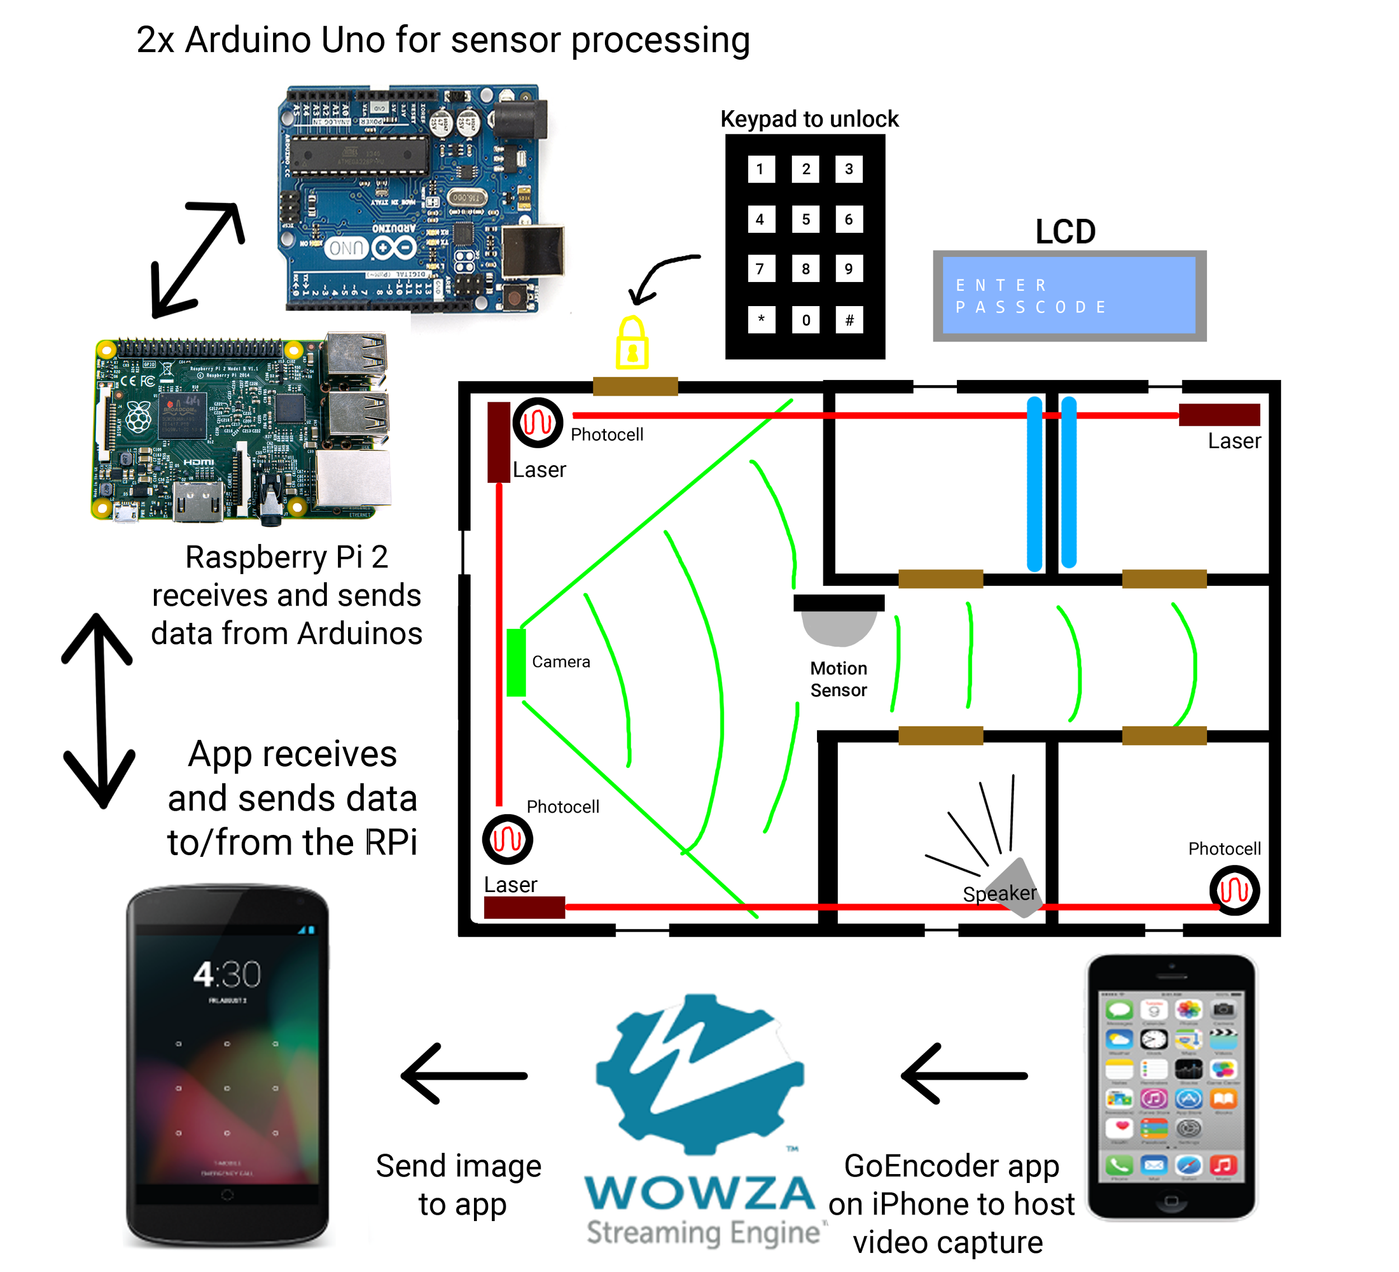

System diagram for the smart home system

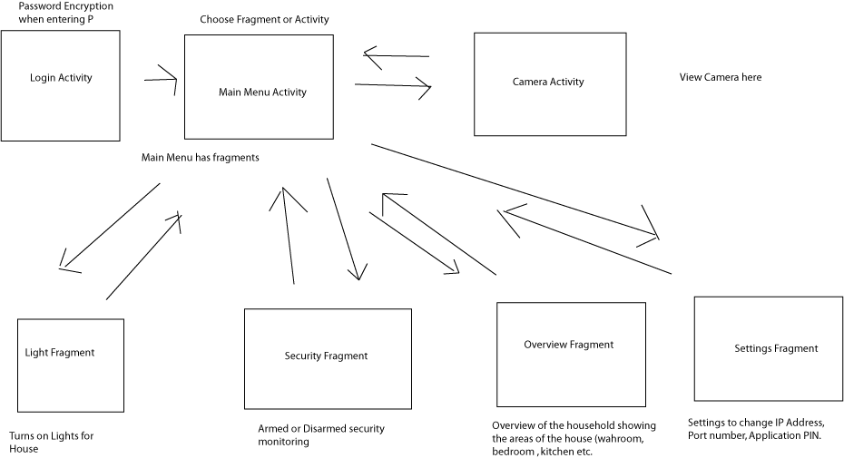

Flowchart of the Android application

# 

# 

# D. Project Description

## The Android Application

The Android application is the interface in which the user will mainly interact with to monitor the security of their own home. Our team first implemented the user interface for the application. The application requires the user to the set a password for the application and entering the password each time the person uses the application. The login feature will first prompt the user for a PIN if one has not been set yet. Once set, a login screen will appear in which the user will need to enter their PIN.

Once the user is able to login to the application, they are directed to the settings menu and prompted to add in the IP Address and Port of the server (the Raspberry Pi) in order to communicate with it through the Internet. The user will also need to input an authentication key in order to have access to sending commands to the server. This authentication key, which is set serverside, prevents hackers and intruders from sending commands to the server. Upon connecting to the Raspberry Pi, the application is ready to use.

Initially, the user will be greeted with an overview of the household; this includes the status of each security feature and the state of the lights in each room. From the main screen, the user can pull out a navigation drawer from the left. This navigation drawer allows the user to enter the security, camera, lights, and settings screen. The drawer also displays the IP Address and Port that were entered by the user.

The security screen displays the status of each security system as well allows the user to arm and disarm the systems using buttons. By pressing the toggle status button for any of the systems, the app will send a command to the server where the command is translated into a serial output to the Arduino. After the Arduino has changed the state of the requested security system, the server will send back a new status string which the app will use to update the displayed statuses. A system trigger such as a laser trip will also alert the app that the system has been compromised. A more detailed explanation of the command processing can be found in the Raspberry Pi Server portion of the report.

Similar to the security screen, the lighting screen will display the status of the lights along with buttons which can turn on or off the lights. Pressing a button will send a command which will prompt the Arduino to toggle the state of the relay, turning on or off the light.

The camera screen will connect to the camera live stream and display the feed in real time. Further explanation of the camera module can be found in the Camera section of the report.

Our settings screen will automatically be in focus if the user has not entered the IP Address, Port, and Authentication Key before. The settings screen allows the user to change the connection values if a change in server info occurs. The user will also be able to change their login PIN if needed. The notification setting also resides in the user settings which toggles the Google Cloud Messaging (GCM) service.

The Google Cloud Messaging (GCM) service is responsible for receiving messages from the Raspberry Pi server and relaying them to the Android device. When the notification setting is first enabled, the app will register with the GCM servers using the API keys provided to us by Google. This allows the app to receive an identification token that is unique for each device. The token will then be sent and stored on the Raspberry Pi server, which the server uses to select the recipients for each message. After the registration process is complete, the device is ready to receive messages, and a listener service is setup to connect to GCM in the background. If any part of the registration process fails, the notification setting will revert back to being disabled.

When a message is received from GCM, our app simply displays the message as a notification. However, it is also possible to implement any other actions after a message, such as opening the app automatically or triggering an emergency call. GCM allows for both upstream and downstream messages to be handled on the app, but we decided to use the downstream portion only. Implementing upstream messages would allow us to send commands remotely through GCM to the Raspberry Pi server.

For any of the screens that requires communications between the application and the Raspberry Pi server, we needed to set up a socket for sending and receiving information. In a screen that requires server communication, the application opens a socket in a background thread. This is important as network connections cannot be run on the main thread in an Android application. Once a socket is opened, the thread goes through a verification process in which the authentication key is exchanged. If successfully verified, a new thread is started. This thread will block on the input buffer on the socket to see if a new status string is sent. When a new status string is received, a function is called that updates the UI for the respective screen. To handle commands to be sent to the server, a sendCommand() method is simply called when any of the UI buttons or sliders is pressed. The method then uses an output buffer to send the string through the socket.

## Model House

For the model house, the team designed the layout for a model house which consisted of several rooms found in a typical household: living room, kitchen, master and regular bedroom, and washroom. The main structure of the house was built using ⅜” thick foam board. A skirt inset below the main floor allowed us to create a basement-like structure to hide all of our electrical components. The main method for adhesion for every piece was hot glue.

Windows and doorways were cut into the walls. These cutouts were made complete with 3D printed doors and window frames that we designed. We also drew floor plans of each room on grid paper instead of building or printed furniture to save on costs and time.

For our interior lighting, we attached the white LED strips to the top of the walls of each room. We 3D printed housings for the PIR motion sensor and laser modules to allow for easier mounting. We placed the three lasers and three photocells into their respective corners such that every window was covered. The PIR motion sensor was mounted between the hallway, the living room and kitchen. A magnet was hot glued on to the back of the front door to use as a trigger for the hall effect sensor that is hovering above the door. On either side of the front door, we have the keypad and the LCD module for password entry. The breadboards, Arduino Unos, relay switches, and Raspberry Pi were attached to the underside of the house using double-sided tape.

## Raspberry Pi Server

An important feature for us was to allow for multiple devices to control the lights simultaneously; this meant we needed to be able to support multiple client connections to the server. We decided to use a Raspberry Pi as it has more computing power than an Arduino to handle these communications. We decided against a WiFi module for the Arduino as it actually cost more than the Raspberry Pi.

We used Java to write our server code because Android application also uses Java so it would be easy to communicate between them. The server utilizes threads to handle the many operations that are occurring. There are 2 main threads that are constantly running as well as additional client threads as needed when they connect.

The first main thread is a handler thread that listens for socket connections from the Android application. Once a client connects, the handler thread creates a new client thread that is used to communicate with the client.

This client thread has two objectives. The first one is to listen for commands from the application. Once a command is received, the thread adds it to a global command queue. Secondly, it will listen for an updated status string in the server. If there is a newly updated status string, the client thread will send in to the Android application. Once the client sends an “exit” command, the thread is stopped.

We did some testing on our original implementation of the sockets and realized that we had a problem. We wrote a small Java client socket program and realized that anyone could connect to our server and create a new thread. The client could send and receive information, or simply end the connection. The server does not know that the client disconnects (a unique trait of sockets) and so there are many idle threads left looping. In order to solve this, we required a authentication key to be entered on the server and the application. This authentication key is then hashed and stored on both ends. When a client connects to the server, the client must send the valid hash value through the socket. If the hash value is the same as the one on the server, the server creates the thread for that client. If it is invalid, it sends a command telling the client that the key is invalid and ends the thread.

The second thread is the Arduino thread that handles the Serial communication between the Raspberry Pi and the Arduino. It has two objectives. When a status string is received by the server from the Arduino, it will update the global status string on the server. The client threads running will sense the update and send the string to the Android application. The second objective is to send any command currently in command queue to the Arduino. Utilizing a queue allows us to stack up commands from all the different client threads so that they can be sent to the Arduino.

This two-way communication system was implemented through the USB serial port with the help of a part of the Pi4J library. Responsibilities of this thread included processing data from the Arduino in the form of the current status of the house and sending data to the Arduino in the form of commands. This offloads much of the extraneous work from the Arduino to the RPi, allowing the Arduino to focus on monitoring the house. Both the RPi and Arduino exhibit similar behaviour when they receive serial input; a serial event is triggered which interrupts the processes of the thread in order to run a function which processes the data received. The RPi expects either a new status string or a string signalling that the Arduino is ready for the next command. Our implementation read the entirety of the serial buffer and splits the string with a specified delimiter before processing all valid substrings. We chose to use binary strings as our status strings as this allows for easy parsing and lowers the amount of data needed to be sent over serial all at once. On the Arduino side, as we had a queue of commands on the RPi, we decided to not used a delimiter parsing method and instead have the Arduino explicitly tell the RPi when it was ready for another command. This ensured that the Arduino did not spend too much time parsing any one serial event and also simplified this parsing process since we could use the bytes available in the Arduino’s serial buffer as a part of this process. The command sent from the RPi would be at most two bytes long, with each byte representing specific information, again improving performance by reducing the time spent writing to serial. Following the same logic, the Arduino would also only write to serial after a change in status of the house in order to reduce unnecessary writes.

When an important event occurs, such as the home’s alarm being triggered, the RPi server can notify users of the Android application remotely through Google Cloud Messaging (GCM). The users do not have be currently connected to the server to receive the notification. As described briefly in the Android Application section of this report, the RPi receives a register command along with a device token from the app. The tokens are stored in a HashSet, which is volatile and will reset when the server restarts. This was convenient for the testing process, but it would have been ideal to have them stored permanently in a separate file.

To notify users of an event, the server calls sendPushNotification() with a message string. This method sends a request to the GCM servers using the HTTP POST protocol, along with the message and device tokens in JSON format. This process requires a sender ID provided by Google, which is unique to our project. The GCM servers will then relay or ‘push’ the message out to the selected devices. Our RPi server currently sends the notification to all registered devices since we assume that there is only one model house. By using extra parameters such as user or device info, we can also choose to notify only specific users.

All of the wireless connection between the Application and the Server is encrypted. The description of this is below in our Encryption/ Hashing section.

## Camera Monitoring

The first step in creating a camera live stream was to have a server to host the data coming from the camera. In this project, we used the Wowza Streaming Engine to host our streaming data so that we can access it using the Android Application in order to play a live stream. After having the server to host data, the data must be sent from a camera. Wowza Streaming Engine requires data to be sent through encoders that it recognizes. In this case, we chose the GoEncoder application for iPhone, which takes the data from the iPhone camera and sends it to Wowza Streaming Engine application. To send the data, we must specify the IP Address and the Port number for the Wowza Streaming Engine application. Once the data is sending, the Android application must receive the data to stream the video. In order to receive data from Wowza Streaming Engine, one must use a protocol for streaming video over the Internet. For this project, we chose to use the Real Time Messaging Protocol (RTMP) over other protocols like RTSP and MJPEG. The reason for using this protocol is because it is compatible with all other parts for the system. We used an external library, Vitamio, to stream the video on the Android application because the standard VideoView user interface element in Android does not support any streaming protocols from Wowza Streaming Engine. Vitamio’s VideoView supports the RTMP protocol to play a video stream and allows us to stream the video stream from Wowza Streaming Engine smoothly. Then, we wrote the XML element to specify the user interface for the camera view. We then wrote the Java code for the Android Application to stream the video. This was done by setting the video player user interface element to path to the RTMP link from Wowza and creating a new MediaController object to start the video by calling the playback() function.

Most problems with the camera live streaming is with the compatibility among the Android, the protocol to stream the live video and the server to host the streaming file. Steps taken to debug were to perform each step iteratively. We first got the video streaming to work by connecting the camera to Wowza Streaming Engine and used the RTMP link generated by Wowza to play on VLC Media Player to check if the stream was correct. The next step was to play the video on Android by writing the code and check if the video plays correctly. Best practices learned from this were to always check compatibility between different protocols and hardware.

## Entrance Password

A password entrance feature is implemented to arm or disarm the security system. First time user will need to choose an eight-digit password to initialize the entrance feature. When inputting the password, the user can see how many digits they have inputted by looking at the number of “*” characters displayed on the LCD. Additionally, if the user wants to delete the previous digit input, they can press the key “#” and the LCD will update correspondingly to reflect the change. The “*” on the keypad will be ignored for the password input. After a password is chosen, the unique hash value from the chosen password will then be stored in the program used to verify future entrance. For entry, the LCD will prompt the person for password input, and the person will have three chance to input the right password. If all three attempts are exhausted, the alarm system will be triggered and a notification will be sent to the owner of the house. The idea behind this is to prevent other people from hacking the password entrance. The triggered alarm can be turned off either by inputting the right password or through the Android app control features. If the user input the right password, a status of “successfully logged” will display on the LCD and the security system will be turned off, since the entrance is verified. After successfully logging in, the user can change the password by pressing the key “*”. The LCD will then prompt the user for the procedures of changing the password. When exiting the house, the user will press the key “#” and then input the password. By doing this, the user will turn on the security system for protection.

To test the password entrance feature, we asked one of our teammates who didn’t know the detailed implementation to play around with the feature. He would rely on the prompt from LCD to complete the following tasks: Initialization, changing password, logging in, and exiting. By doing this, we found out how user friendly our feature is and what the unexpected situations that the user could run in.

## Sensors

To create a functional smart home system within the model house, we needed to implement several sensors to act as the components of each system.

To provide our model house with lighting, we opted to use warm white colored LED strips. Each room was covered with enough lighting strips to simulate a fully lit room. Because these LED strips were rated at 12V, we could not utilize the Arduino nor the RPi’s output voltages to power them. Thus we decided to power the lights with the lab’s DC power supply through a relay module that supported the voltage. To toggle the lights on and off, we hooked up the relay switch to the slave Arduino and controlled our lights from there.

Going beyond the logic of simply digital writing the states of the lights after receiving a command, each one of the five pins used to control the relay channels and LEDs has a variable timer that can also be set from a command by the Android applications. Whenever a light is turned on, the program time is recorded for that light. It is now just a matter of comparing the current program time with this recorded time and checking if the difference is larger than this variable timer. This comparison happens once per loop and although interrupts pause millis(), it was accurate enough by our standards.

For our laser detection feature, our team mounted the three photocells and three laser pointer to the household using glue and tape. To allow the lasers to traverse throughout the house, holes needed to be cut in the intersecting walls. This was done specifically for this project to reduce costs and cut down on processing and in a realistic situation there would be one laser per window. As our proposed laser system only used a single laser, we deemed that it was appropriate with the new setup to combine data from all three lasers and photoresistors in order to maintain the idea that this was still just one system.

The photoresistors share a threshold value where, if armed, will raise a flag if its reading drops below this value. These reading, being analog, are unable to be attached to interrupts and must be read once every main loop. However, it is quite unlikely that someone would have the speed and finesse necessary to cut the laser and get into the house within one main loop. As the system serves no purpose when disarmed, we added a little feature to turn off the lasers during this state.

The motion detection system was composed of a single PIR motion sensor which covered the hallway, living room, and kitchen. The PIR motion sensor was mounted in the hallway using a 3D printed housing and crossbeam. To wire the sensor, we used a 3-wire extension instead of soldering directly onto the breakout board’s pins. The board also allowed us to change the signal that the motion sensor generated using a jumper. Since all we needed was a single high signal to trigger the interrupt we could have used either settings, but in order to check if there was still motion in the house we used the ‘H’ setting. This setting keeps the signal high as long as there is motion detected.

As the PIR motion sensor is able to be read as a digital input, we decided to use one of our two interrupt pins to monitor its status at all times. This by itself however is quite sensitive as any accidental motion would return a high signal. We remedied this by using code which is similar to debouncing a button; the PIR sensor must remain in a certain state for a specified amount of time before we adjust the formal state of our flags. In addition, the logic of our code changes depending on whether the PIR is armed or disarmed. When disarmed, the flag is free to go from detecting motion to not detecting motion. However when armed, the flag will latch to the detecting motion state if it is triggered. This allows us to monitor used the sensor for useful information even when disarmed while maintaining the ability to tell which sensor is triggered when armed where motion should not happen unless there is an intruder.

The door system was composed of a hall effect sensor and a magnet glued to the back of the door. Once the door was opened, the magnet would leave its origin under the hall effect sensor and triggering an interrupt on the Arduino telling it that the door has opened.The state of the hall sensor used the second of our interrupt pins and any change in input triggers this ISR giving us a constant and accurate reading on the state of the door. This information along with whether or not the door was armed at the time allows us to trigger alarms or just monitor the position of the door.

## Encryption & Hashing

Passwords are required when entering the house, connecting to the RPi server, or logging into the Android application. We have to make sure that the user’s passwords are secure in our implementation, so hash functions are implemented for each password. With the hash function, the hash value of the password will be stored in the program or the database instead of the plaintext password itself. We implemented at least two layers of protection to make sure the hashing process is difficult to hack or reverse. Therefore, we have no access to the actual password, and the end-user’s privacy is secured.

For the password used to enter the house, it is an eight-character password consisting of only numbers. For the first layer of protection, we swap certain characters in the password. Since swapping is a injective process, it ensures that every output comes from an unique input. After swapping, we will map the swapping output into a power function to magnify the value, so that a small change of the password will result in a large change in the hash value. After this, we added two uniquely chosen prime number to the output, which forms the final output for the hash value.

For the password used to login in the Android app, it is a string with a minimum length of 6 characters consisting of the lower-case alphabet and numbers. Similar to the house password, we swap some characters in the string for the first layer of protection. Then, we use the ASCII value of each characters in the string to map to an array that contains 36 unique random strings. The final result of the mapping will be the hash value for the password.

For the RPi server communication security, we append an unique string (an authentication key) to the information we are sending, so that the server would know if the commands being sent are actually coming from the intended users. The command we are sending is already encrypted within the implementation of the server(in other word, the string content only makes sense within our implementation).

# 

# 

# E. References and Bibliography

Server:

<http://pi4j.com/index.html> - Pi4J project for libraries, documentation, and examples

Android:

<http://developer.android.com/index.html> - References for Android libraries

<http://stackoverflow.com/> - Forum posts for examples of Android layout and UI elements

<https://vitamio.org/> - Vitamio Library for the VideoView

<http://android-er.blogspot.ca/2014/02/android-sercerclient-example-server.html> - Server Socket Example

<https://github.com/googlesamples/google-services/tree/master/android/gcm> - Reference program for GCM

<http://android-er.blogspot.ca/2014/02/android-sercerclient-example-client.html> - Server Socket Client Example Code

# 

# 

# Appendix A – Project Pictures

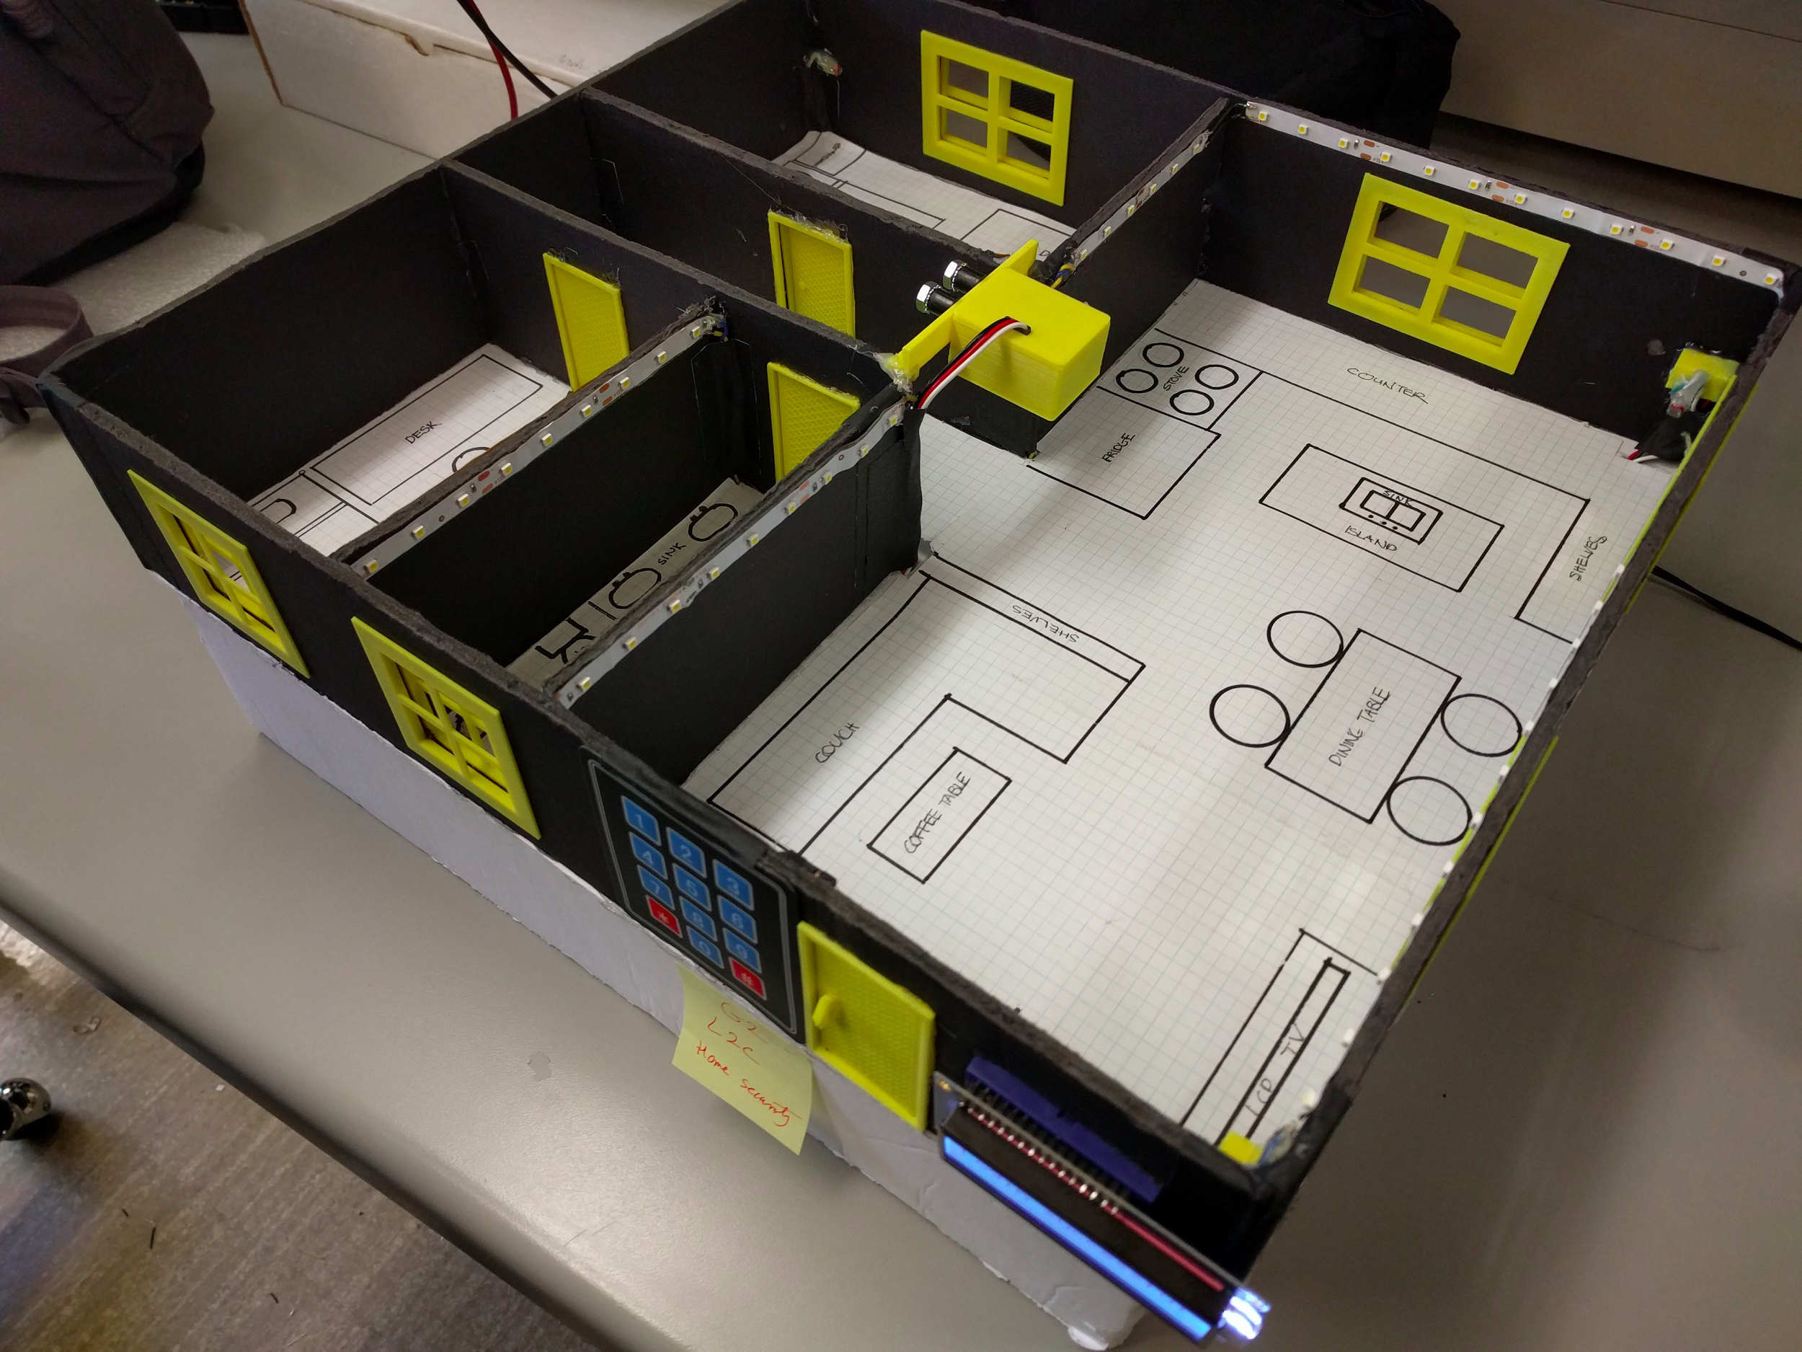

Overview of the household model

# 

Overall circuitry, sensor processing, and server modules

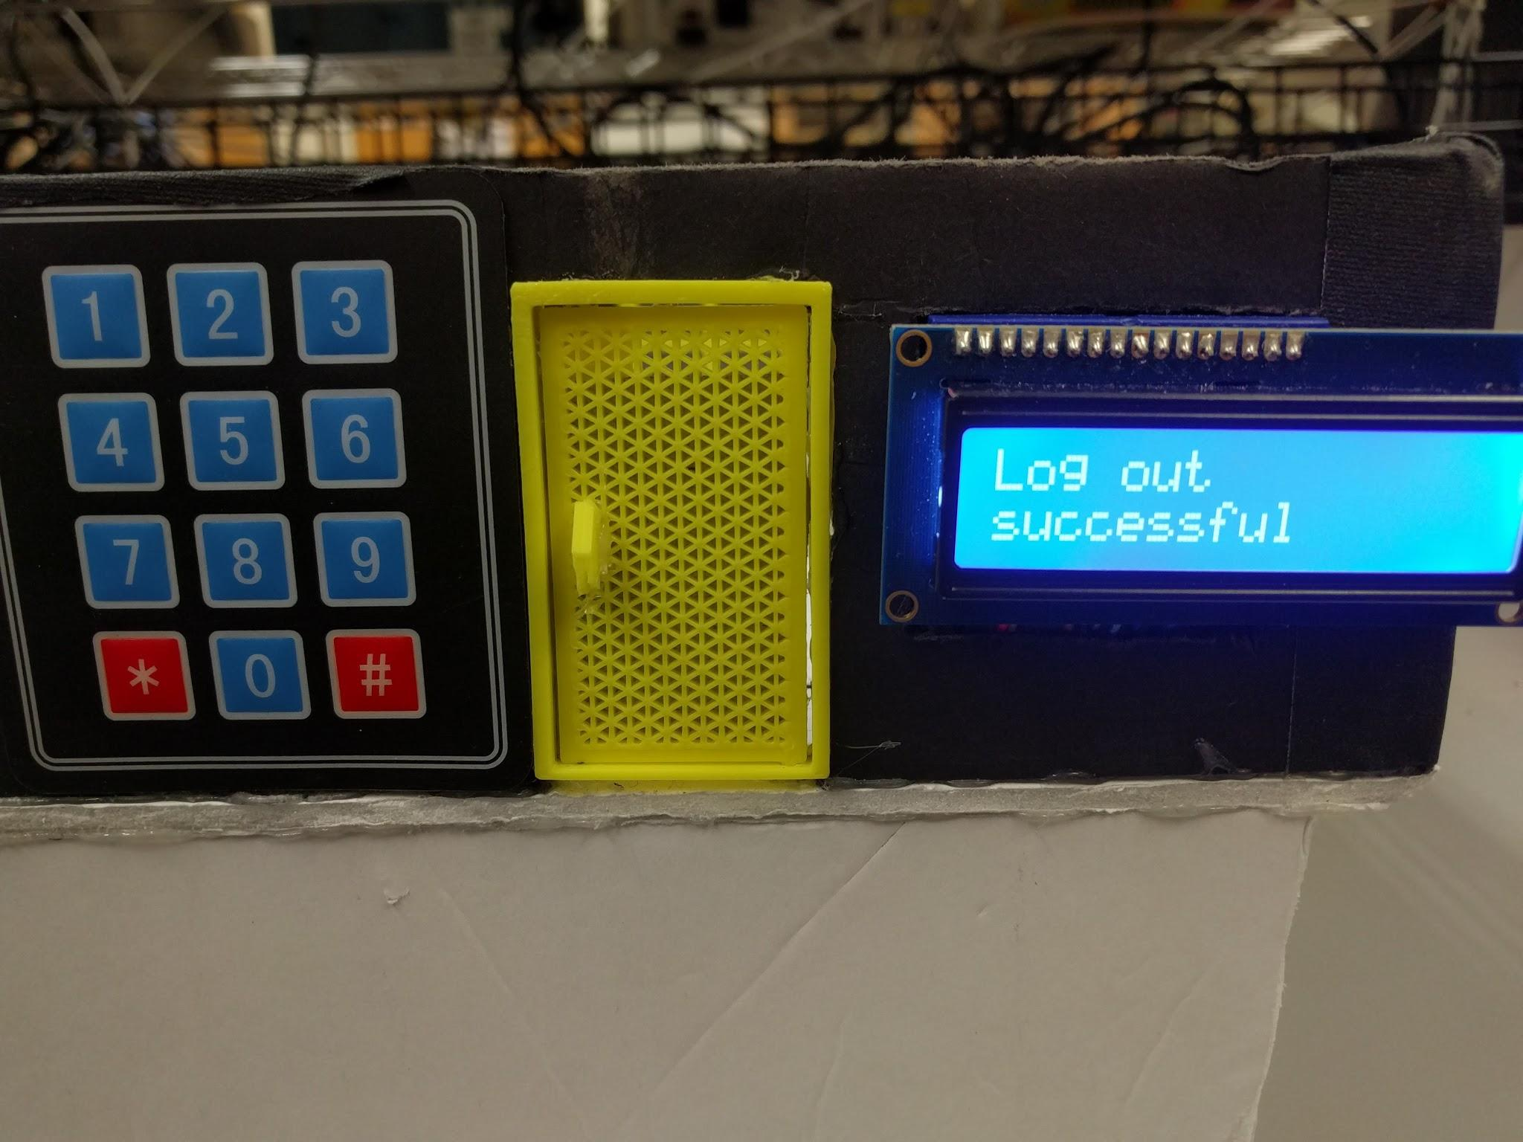

Front view of the household

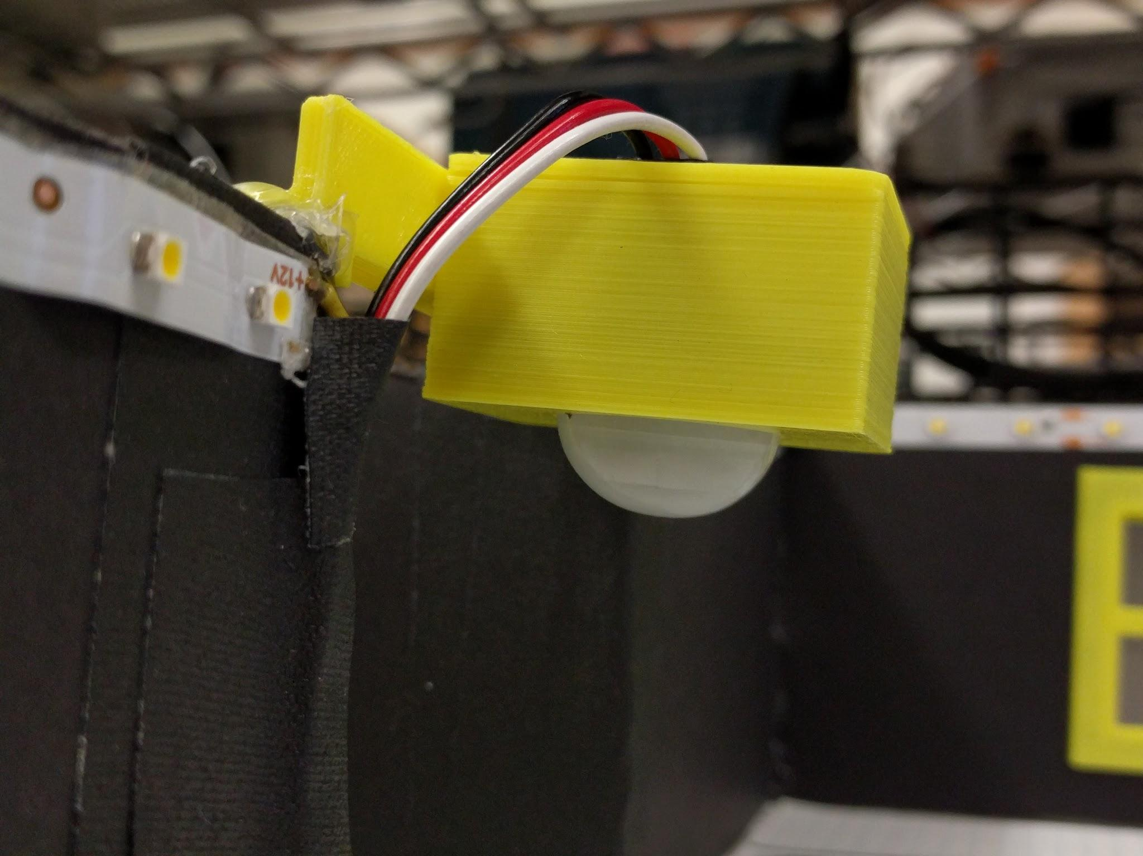

PIR motion sensor for detecting motion inside household

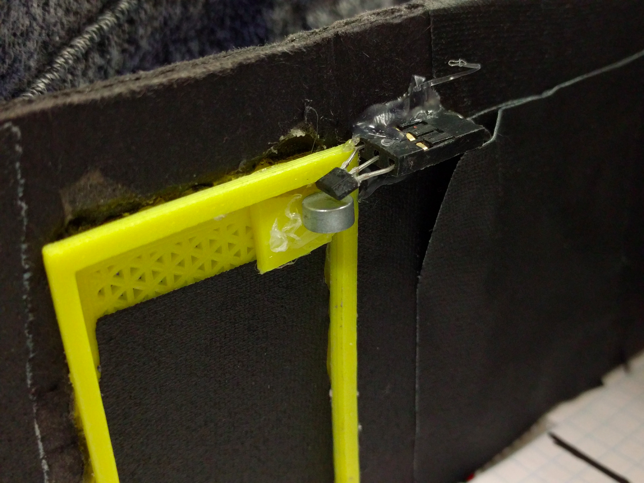

Hall effect sensor with magnet on the door

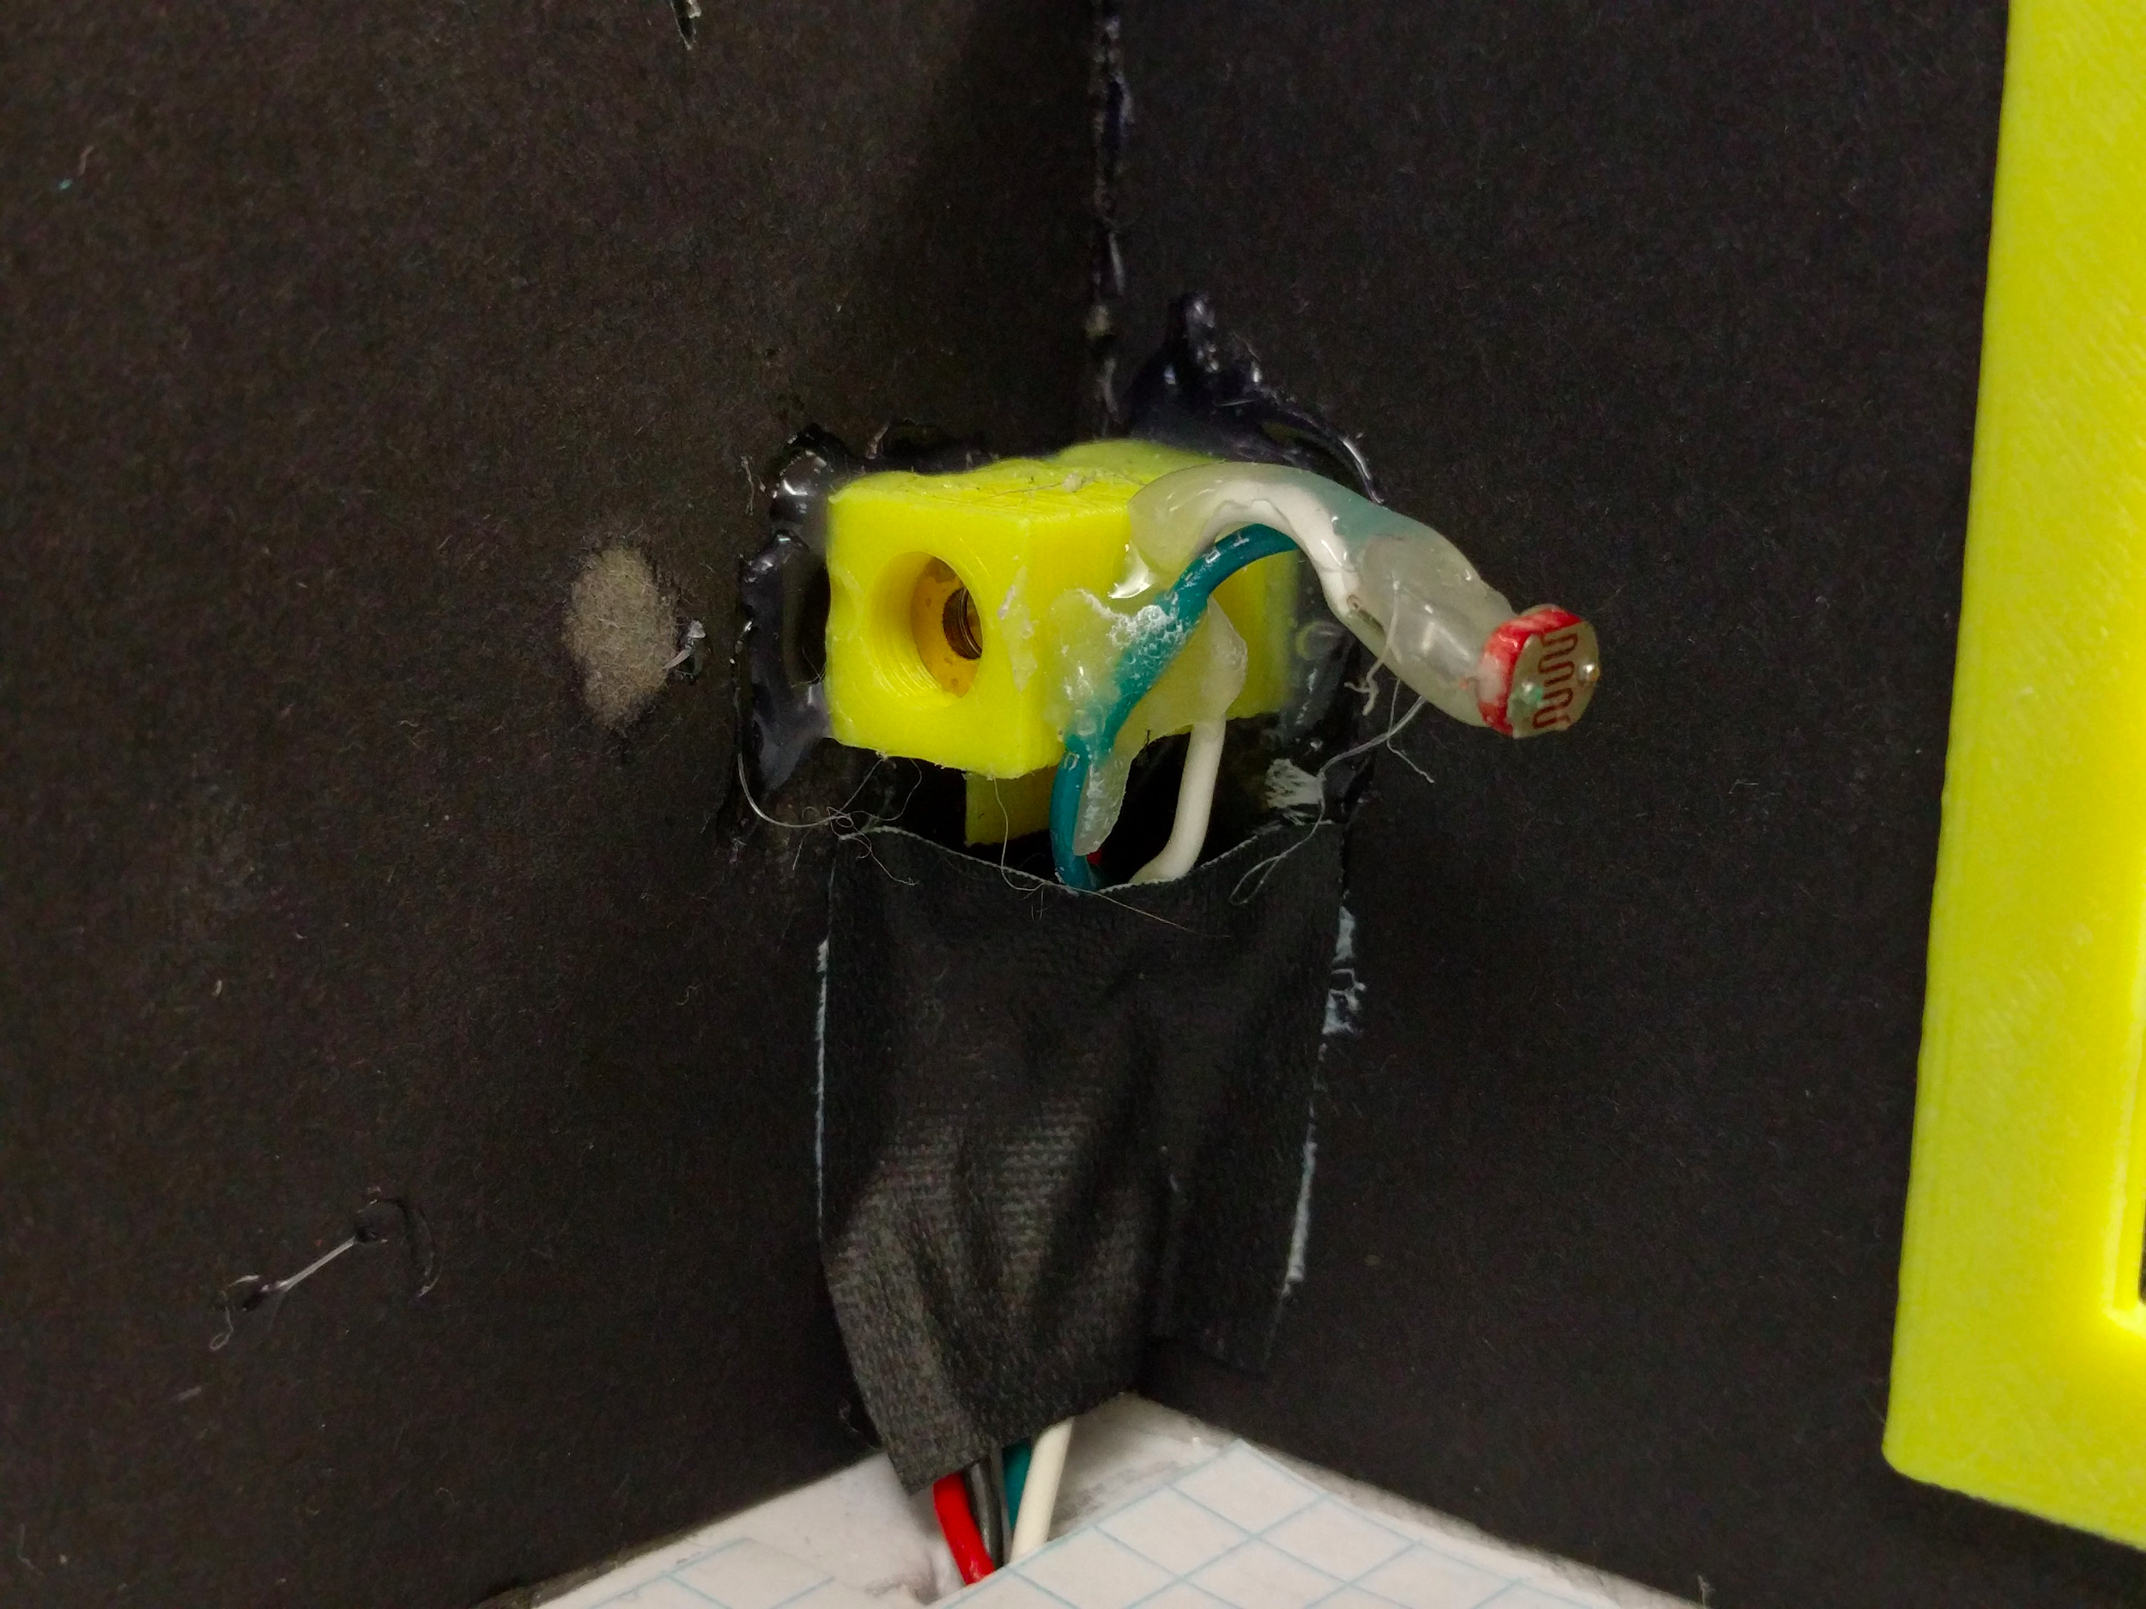

Laser and photocell combination for detecting intruders from windows

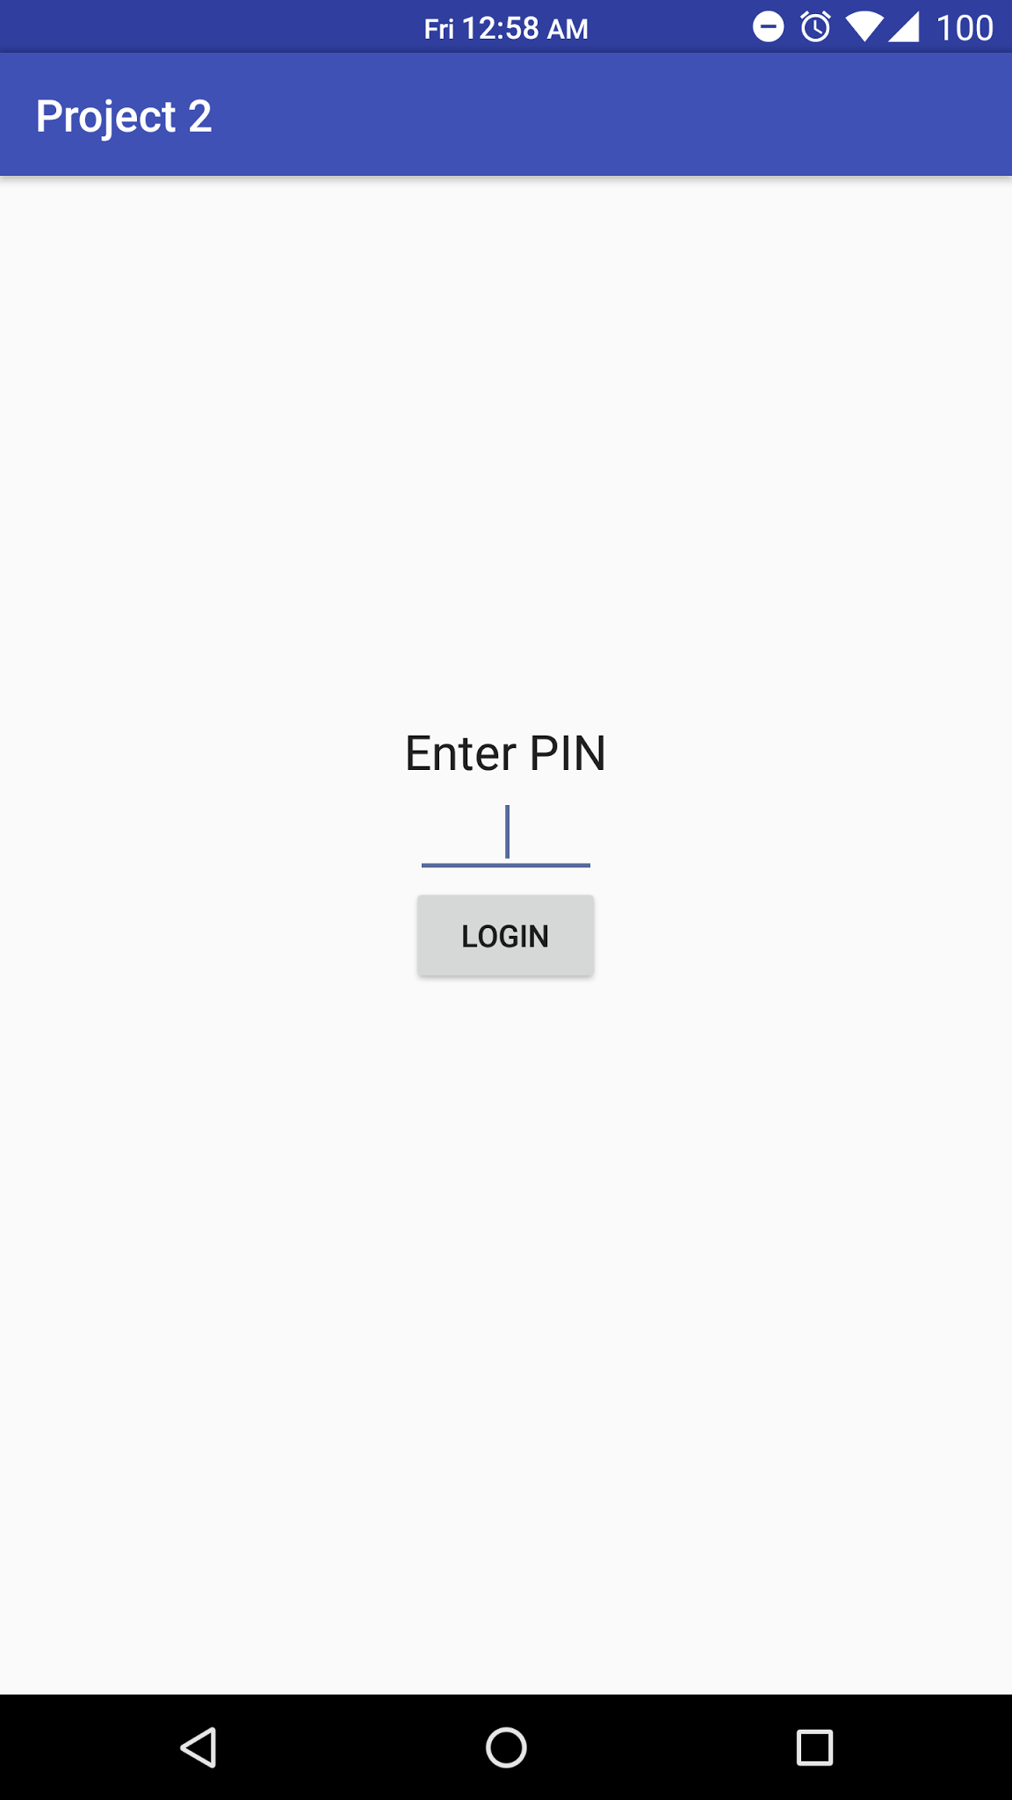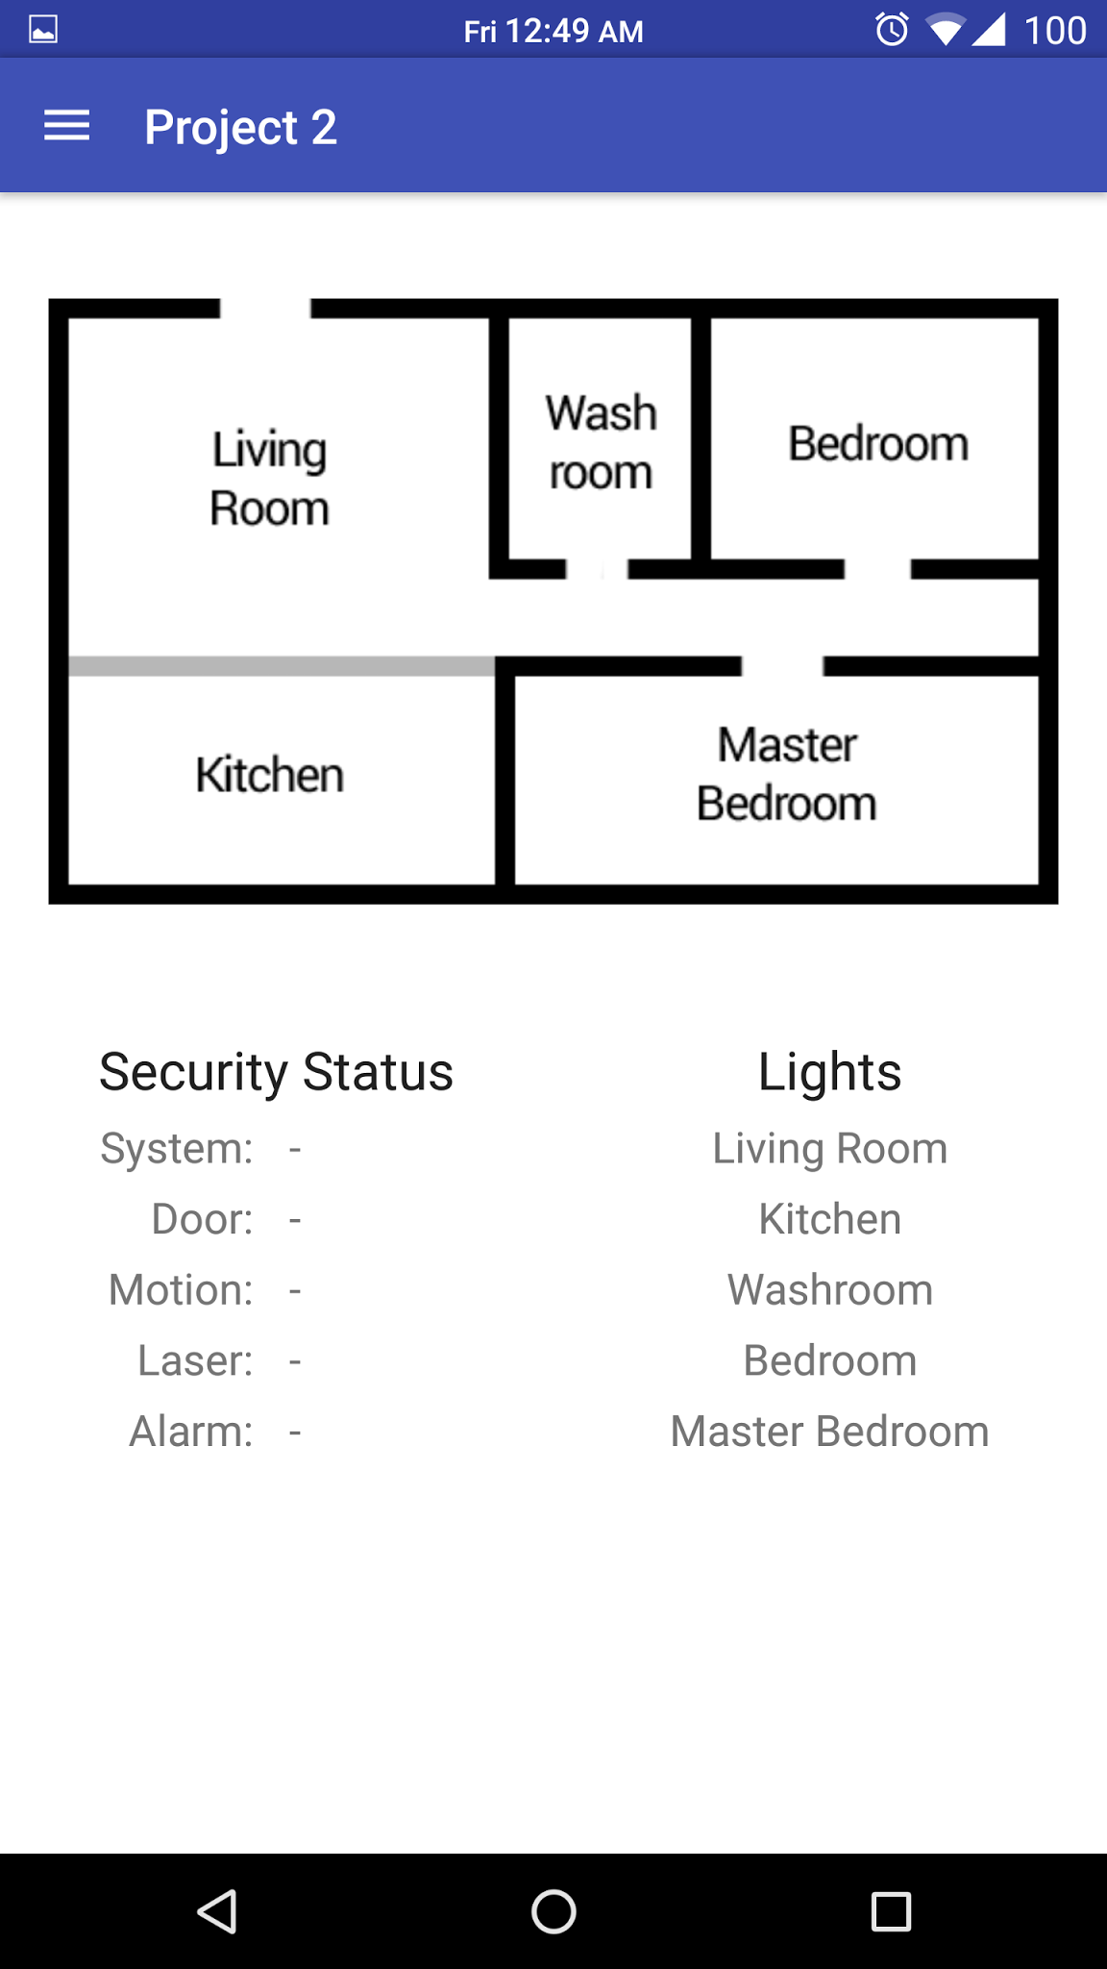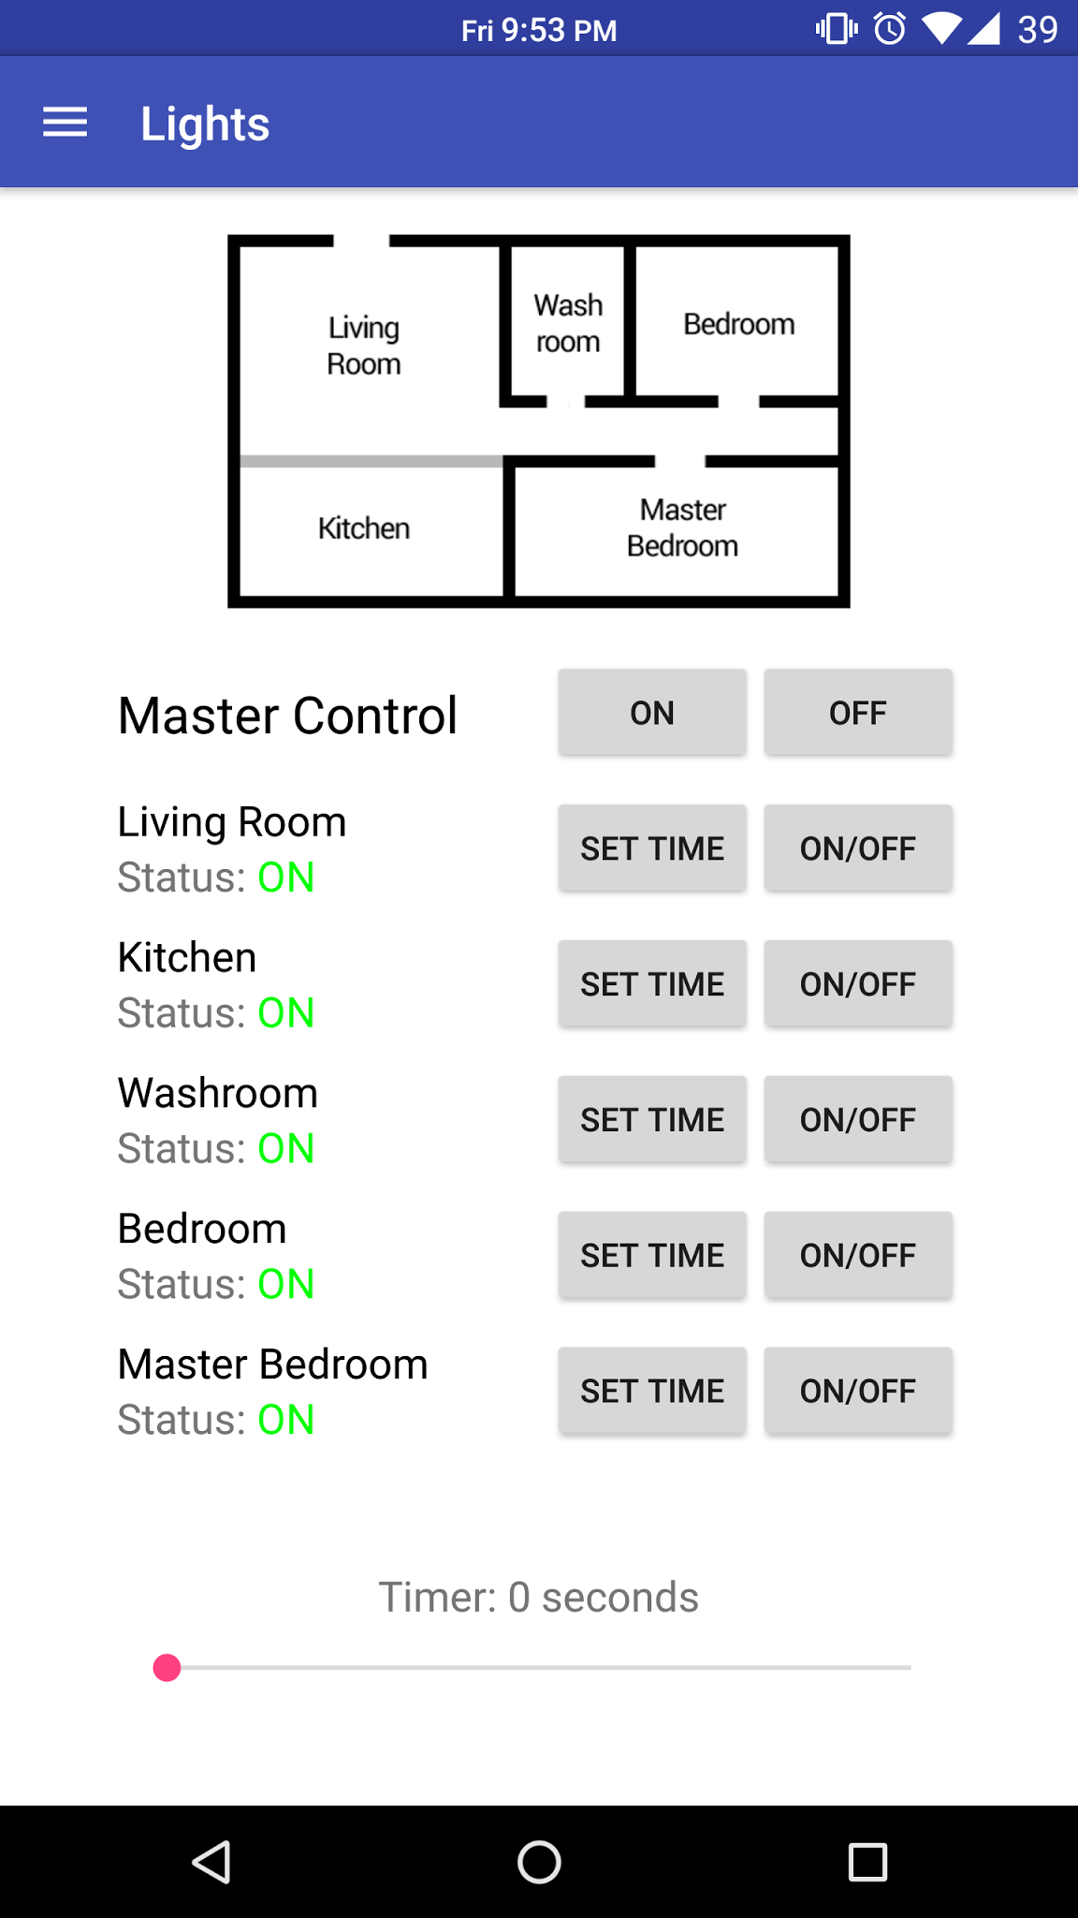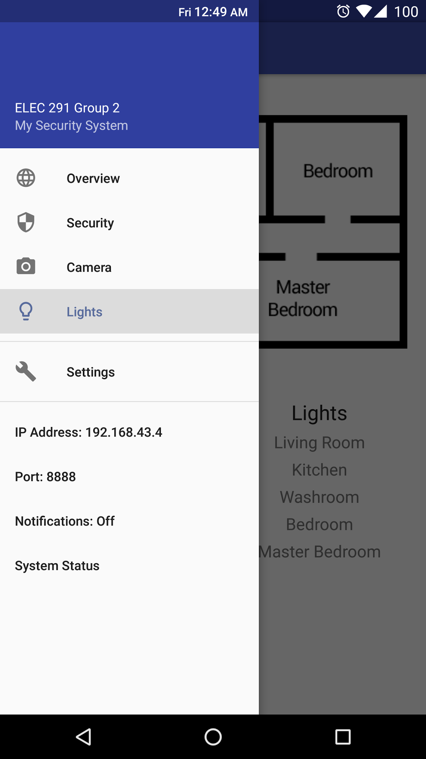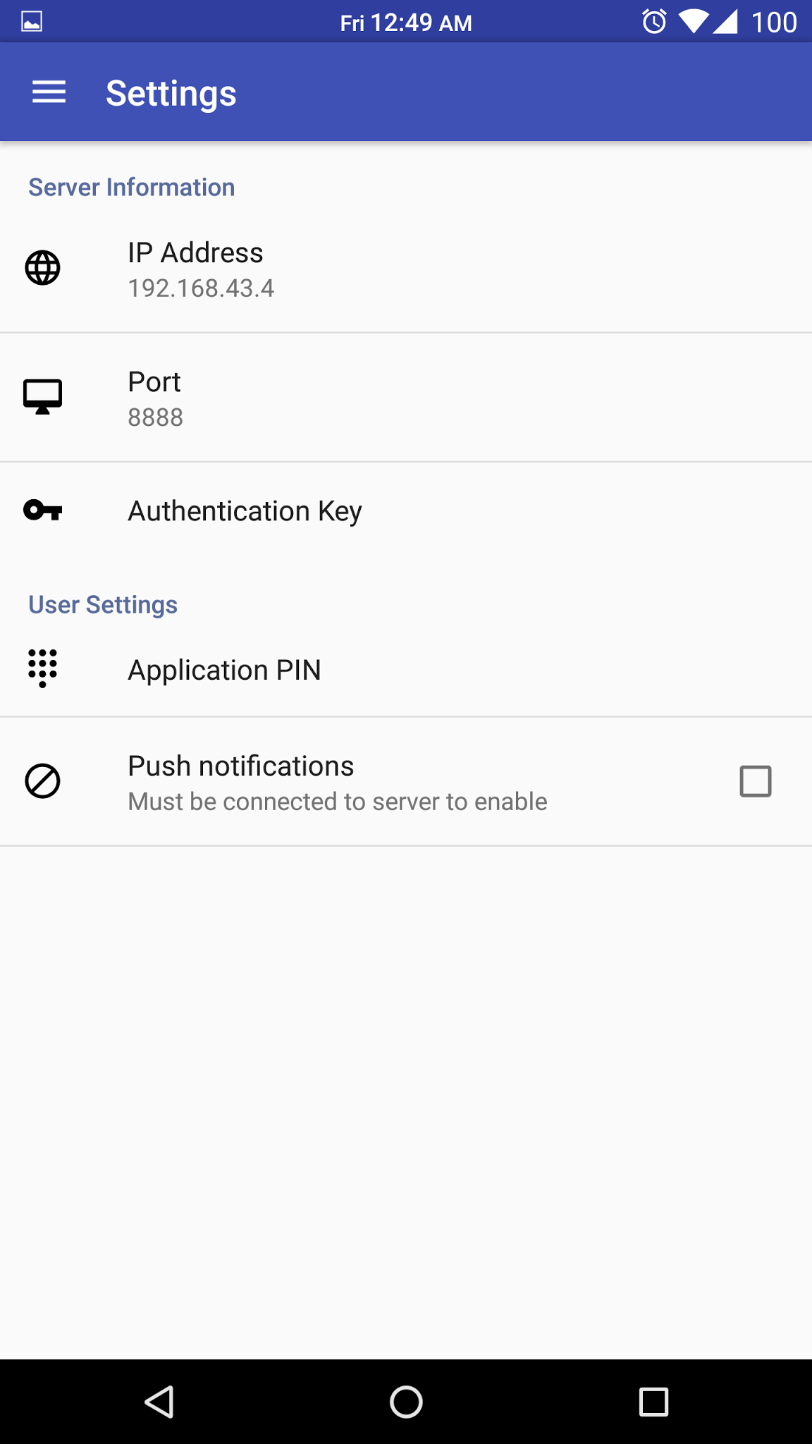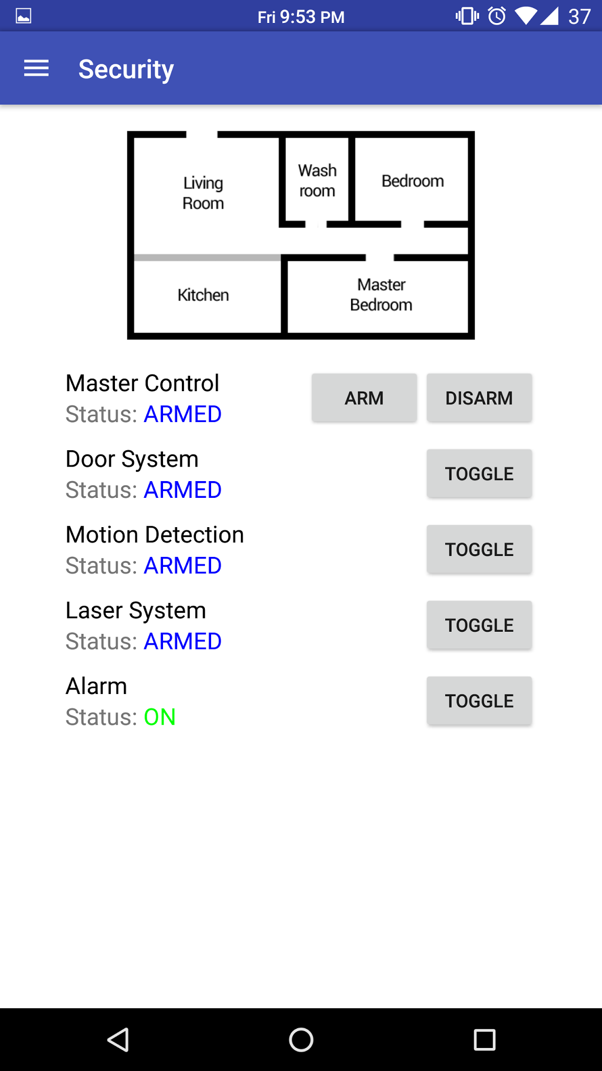

Screenshots of the Android application

# 

# 

# Appendix B - Fritzing

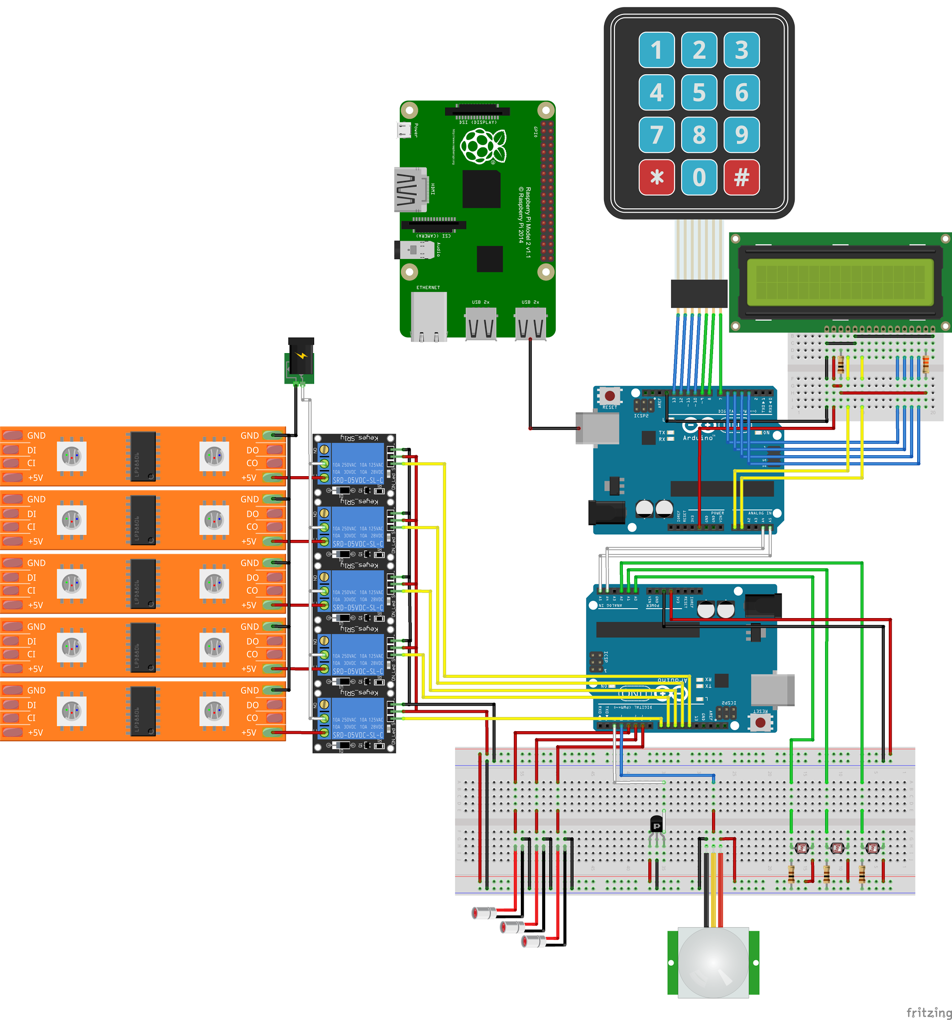

Fritzing schematic

# 

# 

# Appendix C – Arduino Code

## Master Code (Keypad and LCD)

|  |
| --- |
| #include <Wire.h>  #include <Key.h>  #include <Keypad.h>  #include <LiquidCrystal.h>  /////////////////////////////////////////////////  // KeyPad //  /////////////////////////////////////////////////  const byte ROWS = 4; //four rows  const byte COLS = 3; //three columns  //keypad layout  char keyPad[4][3] = {  {'1', '2', '3'},  {'4', '5', '6'},  {'7', '8', '9'},  {'*', '0', '#'}  };  //pin number  byte KeyRowP[ROWS] = {13, 12, 11, 10};  byte KeyColP[COLS] = {9, 8, 7};  //other variables for keypad  int debounceTime = 1000;  char lastInput = ' ';  Keypad keypad = Keypad( makeKeymap(keyPad), KeyRowP, KeyColP, ROWS, COLS );  /////////////////////////////////////////////////  // LCD //  /////////////////////////////////////////////////  //tested correect pins  LiquidCrystal lcd(A1, A0, 6, 5, 4, 3);  //password  long password_hash_value = 0;  boolean password_exist = false;  const int PASSWORD_MAX_LENGTH = 8;  boolean verified_log_in = false;  const int time_between_input = 2000;  int verify_attempts = 3;  //security constant  #define disarm 0  #define arm 1  #define turn_off_and_disarm 2  #define turn_on_alarm 3  /////////////////////////////////////////////////  // Execution //  /////////////////////////////////////////////////  void setup() {  // put your setup code here, to run once:  Serial.begin(9600);  Wire.begin();  lcd.begin(16, 2);  }  void loop() {  //check if a password is set up  if(!password_exist) initialize_menu();  //prompt the user for logging in  while(!verified_log_in&&verify_attempts!=0){  lcd.clear();  lcd.print("Enter password");  lcd.setCursor(0,1);  lcd.print("for entrance");  if(input_password()){  lcd.clear();  lcd.print("Login successful");  //update the attempt number and send the verified log in status to be true  verify_attempts=3;  verified_log_in=true;  //send the disarm message  sendToSlave(disarm);  delay(2000);  }  else{  lcd.clear();  lcd.print("Wrong password");  lcd.setCursor(0,1);  lcd.print("Try again");  //decrement the attempt number  verify_attempts--;  delay(2000);  }  }  //things to do when exhausted the attempts  if(verify_attempts==0){  sendToSlave(turn_on_alarm);  lcd.clear();  lcd.print("Enter password");  lcd.setCursor(0,1);  lcd.print("to turn off");  if(input_password()){  //turn off the alamr upon successful input  sendToSlave(turn_off_and_disarm);  //resent the attempt number and set the log in status to be true  verify_attempts=3;  verified_log_in=true;  lcd.clear();  lcd.print("Login successful");  }  }    //check if the user want to change the password  char current_reading = keypad.getKey();  if(current_reading=='*'){  change_password();  }  //check if the user want to exit and turn on the security system  if(current_reading=='#'){  lcd.clear();  lcd.print("Enter password again");  lcd.setCursor(0,1);  lcd.print("to exit");  if(input_password()){  lcd.clear();  lcd.print("Log out ");  lcd.setCursor(0,1);  lcd.print("successful");  verified_log_in=false;  verify_attempts=3;  sendToSlave(arm);  delay(2000);  }  else{  lcd.clear();  lcd.print("Wrong password");  lcd.setCursor(0,1);  lcd.print("try again");  }  }  }  //send to slave  void sendToSlave(byte x) {  Wire.beginTransmission(8);  Wire.write(x);  Wire.endTransmission();  }  /////////////////////////////////////////////////  // Interface //  /////////////////////////////////////////////////  void initialize_menu(){  //welcome message  lcd.clear();  lcd.noAutoscroll();  lcd.setCursor(0, 0);  lcd.print("Initial set up ");  delay(1000);  lcd.clear();  lcd.setCursor(0, 0);  lcd.print("Choose an eight-digit");  lcd.setCursor(0, 1);  lcd.print("password");  delay(1000);  initial_password();  }  /////////////////////////////////////////////////  // password //  /////////////////////////////////////////////////  //method used to initialize password  void initial_password() {  //message to prompt the user for password  int input[PASSWORD_MAX_LENGTH] = {0};  boolean finished = false;  //keep reading until the user finish input  char currentReading;  int character_num = 0;    lcd.clear();  lcd.setCursor(0, 0);  lcd.print("Choose a eight-");  lcd.setCursor(0,1);  lcd.print("digit password");  while (!finished) {  currentReading = keypad.waitForKey();  //if key ="#", delete the previous input  if (currentReading == '#') {  character_num--;  lcd_display_pw(character_num);  }  else if(currentReading == '*'){  lcd.print("not legal input");  lcd_display_pw(character_num);  }  else{  input[character_num]=char_to_int(currentReading);  character_num++;  lcd_display_pw(character_num);  }  if(character_num==8) finished=true;  }  //for testing  // Serial.print("\n");  // Serial.print("content for the stored hash: ");  // for(int i=0; i<PASSWORD_MAX_LENGTH; i++){  // Serial.print(input[i]);  // }  // Serial.print("\n");    password_hash_value = hash_function(input);  password_exist=true;    //for testing  // Serial.print("\n");  // Serial.print("hash value is: ");  // Serial.print(password_hash_value);  // Serial.print("\n");  }  void change_password() {  int input[PASSWORD_MAX_LENGTH]={0};  boolean finished = false;  //keep reading until the user finish input  char currentReading;  int character_num=0;    lcd.clear();  lcd.print("Input the new");  lcd.setCursor(0,1);  lcd.print("password");    while (!finished) {  currentReading = keypad.waitForKey();  if (currentReading == '#') {  character_num--;  lcd_display_pw(character_num);  }  else if(currentReading == '*'){  lcd.print("not legal input");  lcd_display_pw(character_num);  }  else{  input[character_num]=char_to_int(currentReading);  character_num++;  lcd_display_pw(character_num);  }    if(character_num==8) finished=true;  }    password_hash_value = hash_function(input);    lcd.clear();  lcd.print("Password changed");  lcd.setCursor(0,1);  lcd.print("successfully");  delay(2000);  }  boolean verify_password(int* input) {  //for testing  // Serial.print("\n");  // Serial.print("stored hash value");  // Serial.print(password_hash_value);  // Serial.print("\n");  //  // Serial.print("\n");  // Serial.print("the input is: ");  // for(int i=0; i<PASSWORD_MAX_LENGTH; i++){  // Serial.print(input[i]);  // }  // Serial.print("\n");  //  // Serial.print("the input hash is");  // Serial.print(hash_function(input));    if (hash_function(input)==(password_hash_value)) return true;  return false;  }  //read password from user  boolean input_password() {  int input[PASSWORD_MAX_LENGTH] = {0};  boolean finished = false;  //keep reading until the user finish input  char currentReading;  int character_num=0;  while (!finished) {  currentReading = keypad.waitForKey();  if (currentReading == '#') {  character_num--;  lcd_display_pw(character_num);  }  else if(currentReading == '*'){  lcd.print("not legal input");  lcd_display_pw(character_num);  }  else{  input[character_num]=char_to_int(currentReading);  character_num++;  lcd_display_pw(character_num);  }  if(character_num==8) finished=true;  }  //for testing  Serial.print("\n");  Serial.print("the input is ");  Serial.print(verify_password(input));  Serial.print("\n");    return verify_password(input);  }  //display password on the lcd  void lcd_display_pw(int n){  lcd.clear();  lcd.setCursor(0, 0);  lcd.print("Password:");  lcd.setCursor(0, 1);  //might need adjustment  for(int i=0; i<n; i++){  lcd.print("*");  }  }  //convert the password into a integer hash value  long hash_function(int input[]) {  first_layer_encryption(input);  int i;  long hash_value = 0 ;  long intermediate= 0 ;  for (i = 0; i < PASSWORD_MAX_LENGTH; i++) {  intermediate += input[i] * pow(10, i);  }  //for testing  // Serial.print("\n");  // Serial.print("the input intermediate is: ");  // Serial.print(intermediate);  // Serial.print("\n");      hash_value = intermediate + 3 * 7823 + 2 * 5783;  //for testing  // lcd.clear();  // lcd.print("hash is");  // lcd.print(hash_value);  return hash_value;  }  //first layer of encription: encript the int array  void first_layer_encryption(int* input) {  swap(input, 0, 7);  swap(input, 3, 6);  swap(input, 4, 5);  }  //swap two elements in the array  void swap(int* input, int index1, int index2) {  int intermediate = 0;  intermediate = input[index1];  input[index1] = input[index2];  input[index2] = intermediate;  }  //turn char into corresponding int value  int char_to_int(char a){  switch (a){  case '0': return 0; break;  case '1': return 1; break;  case '2': return 2; break;  case '3': return 3; break;  case '4': return 4; break;  case '5': return 5; break;  case '6': return 6; break;  case '7': return 7; break;  case '8': return 8; break;  case '9': return 9; break;  }  } |

## Slave Code (Sensors and Security)

|  |
| --- |
| #include <Wire.h>  // sensor pins  #define DOOR_HALL_PIN 3 // ON ISR  #define PIR_PIN 2 // ON ISR  #define PCELL0_PIN A0  #define PCELL1_PIN A1  #define PCELL2_PIN A2  #define LASER0_PIN 9  #define LASER1_PIN 10  #define LASER2_PIN 11  // light pins  #define LIGHT0_PIN 4 // washroom  #define LIGHT1_PIN 5 // bedroom  #define LIGHT2_PIN 6 // living room  #define LIGHT3_PIN 7 // kitchen  #define LIGHT4_PIN 8 // master bedroom  const long motionDetectTime = 500; // max time that motion is detected before alarm triggers  const int pCellAlarmThreshold = 125; // max pcell value before alarm triggers  // arm/disarm alarms  int doorArmed = 0;  int pirArmed = 0;  int pCellArmed = 0;  // light status  int light0Status = 0;  int light1Status = 0;  int light2Status = 0;  int light3Status = 0;  int light4Status = 0;  //light timers  unsigned long light0Timer = 0;  unsigned long light1Timer = 0;  unsigned long light2Timer = 0;  unsigned long light3Timer = 0;  unsigned long light4Timer = 0;  // max time that a light will remain on (default ~60s)  unsigned long light0OnTime = 60000;  unsigned long light1OnTime = 60000;  unsigned long light2OnTime = 60000;  unsigned long light3OnTime = 60000;  unsigned long light4OnTime = 60000;  // alarms and flags  int doorAlarm = 0;  int pirAlarm = 0;  int pirStatus = 0;  int pCellAlarm = 0;  int triggered = 0;  int pwTrigger = 0;  int manualAlarm = 0;  // status strings  String prevStatusStr = "";  void setup() {  Serial.begin(38400); // default rpi baud rate  Wire.begin(8);  Wire.onReceive(recieveEvent); // listening to lcd+keypad arduino to arm/disarm system  prevStatusStr.reserve(16); // reserve 16 bytes (arbitary) to store the previous status string  // set up interrupt  attachInterrupt(digitalPinToInterrupt(DOOR_HALL_PIN), doorHallISR, CHANGE);  attachInterrupt(digitalPinToInterrupt(PIR_PIN), motionSensISR, CHANGE);  // pinmodes  pinMode(LIGHT0_PIN, OUTPUT);  pinMode(LIGHT1_PIN, OUTPUT);  pinMode(LIGHT2_PIN, OUTPUT);  pinMode(LIGHT3_PIN, OUTPUT);  pinMode(LIGHT4_PIN, OUTPUT);  pinMode(LASER0_PIN, OUTPUT);  pinMode(LASER1_PIN, OUTPUT);  pinMode(LASER2_PIN, OUTPUT);  // initialize laser and light states  digitalWrite(LIGHT0_PIN, HIGH);  digitalWrite(LIGHT1_PIN, HIGH);  digitalWrite(LIGHT2_PIN, HIGH);  digitalWrite(LIGHT3_PIN, HIGH);  digitalWrite(LIGHT4_PIN, HIGH);  int lasers = pCellArmed ? HIGH : LOW;  controlLasers(lasers);  }  void loop() {  checkAndTriggerAlarms();  // send new status string if it changed from old one  String statusStr = createStatusStr();  if ( !statusStr.equals(prevStatusStr) ) {  Serial.print(statusStr);  prevStatusStr = statusStr;  }    powerSaveLights();  }  //////////////////////////////////////////////////////  // SYSTEM CONTROL CODE //  //////////////////////////////////////////////////////  /*  * Create a binary status string containing all information needed for RPi to process the state of the house.  */  String createStatusStr() {  String s; // byte #  s.concat(triggered); // 0  s.concat(pwTrigger); // 1  s.concat(doorAlarm); // 2  s.concat(pirAlarm); // 3  s.concat(pCellAlarm); // 4  s.concat(doorArmed); // 5  s.concat(pirArmed); // 6  s.concat(pCellArmed); // 7  s.concat(manualAlarm); // 8  s.concat(light0Status); // 9  s.concat(light1Status); // 10  s.concat(light2Status); // 11  s.concat(light3Status); // 12  s.concat(light4Status); // 13  s.concat(":"); // 14 - delimiter  return s;  }  /*  * Process commands from the RPi to adjust the state of the system.  */  void serialEvent() {  delay(10); // wait for all data to be written  if ( Serial.available() == 1 ) { // security commands  int x = Serial.read() - '0';  switch (x) {  case 0: // alarm off  turnOffAndResetAlarms();  break;  case 1: // alarm on  manualAlarmOn();  break;  case 2: // arm entire system  controlLasers(HIGH);  delay(10);  doorArmed = pirArmed = pCellArmed = 1;  break;  case 3: // disarm entire system  doorArmed = pirArmed = pCellArmed = 0;  delay(10);  controlLasers(LOW);  break;  case 4: // arm door hall sensor  doorArmed = 1;  break;  case 5: // arm motion sensor  pirArmed = 1;  break;  case 6: // arm lasers  controlLasers(HIGH);  delay(10);  pCellArmed = 1;  break;  case 7: // disarm door hall sensor  doorArmed = 0;  break;  case 8: // disarm motion sensor  pirArmed = 0;;  break;  case 9: // disarm lasers  pCellArmed = 0;  delay(10);  controlLasers(LOW);  break;  default: break;  }  }  else if ( Serial.available() == 2 ) { // light commands  int light = Serial.read() - '0'; // convert from ascii to byte value  if ( light >= 0 && light <= 5 ) {  int set = Serial.read() - '0'; // convert from ascii to byte value  int state = set ? LOW : HIGH;  // turn on and off lights  switch (light) {  case 0:  digitalWrite(LIGHT0_PIN, state);  light0Status = set;  light0Timer = millis();  break;  case 1:  digitalWrite(LIGHT1_PIN, state);  light1Status = set;  light1Timer = millis();  break;  case 2:  digitalWrite(LIGHT2_PIN, state);  light2Status = set;  light2Timer = millis();  break;  case 3:  digitalWrite(LIGHT3_PIN, state);  light3Status = set;  light3Timer = millis();  break;  case 4:  digitalWrite(LIGHT4_PIN, state);  light4Status = set;  light4Timer = millis();  break;  case 5:  digitalWrite(LIGHT0_PIN, state);  digitalWrite(LIGHT1_PIN, state);  digitalWrite(LIGHT2_PIN, state);  digitalWrite(LIGHT3_PIN, state);  digitalWrite(LIGHT4_PIN, state);  light0Timer = light1Timer = light2Timer = light3Timer = light4Timer = millis();  light0Status = light1Status = light2Status = light3Status = light4Status = set;  break;  default: break;  }  }  // set timers for lights  else if ( light >= 6 && light <= 10 ) {  unsigned long setTime = (byte)Serial.read() * 1000.0;  switch (light) {  case 6:  light0OnTime = setTime;  break;  case 7:  light1OnTime = setTime;  break;  case 8:  light2OnTime = setTime;  break;  case 9:  light3OnTime = setTime;  break;  case 10:  light4OnTime = setTime;  break;  default: break;  }  }  }  Serial.print("r:"); // tell RPi that Arduino is ready for next command  }  /*  * Process commands from the keypad+lcd Arduino.  */  void recieveEvent(int howMany) {  if (Wire.available()) {  int x = Wire.read();  switch (x) {  case 0: // pw correct, disarm systems  doorArmed = pirArmed = pCellArmed = 0;  delay(10);  controlLasers(LOW);  break;  case 1: // owner leaving, arm systems  controlLasers(HIGH);  delay(10);  doorArmed = pirArmed = pCellArmed = 1;  break;  case 2: // pw correct, disable alarm, disarm systems  doorArmed = pirArmed = pCellArmed = 0;  delay(10);  controlLasers(LOW);  pwTrigger = manualAlarm = 0;  break;  case 3: // pw incorrect, sound alarm  pwTrigger = manualAlarm = 1;  break;  }  }  }  /*  * Reset the system to a disarmed state without alarms.  */  void turnOffAndResetAlarms() {  doorAlarm = pirAlarm = pCellAlarm = doorArmed = pirArmed = pCellArmed = triggered = pwTrigger = manualAlarm = pirStatus = 0;  delay(10);  }  /*  * Turn on the alarm.  */  void manualAlarmOn() {  manualAlarm = 1;  }  /*  * Turn on/off the lasers.  * Note: Disarm the laser system before turning lasers off.  */  void controlLasers(int state) {  digitalWrite(LASER0_PIN, state);  digitalWrite(LASER1_PIN, state);  digitalWrite(LASER2_PIN, state);  }  //////////////////////////////////////////////////////  // MONITORING AND ALARM CODE //  //////////////////////////////////////////////////////  /*  * Check if lights have been on for longer than their respective lightOnTime.  * Turn off that light if it is the case.  */  void powerSaveLights() {  unsigned long currTime = millis();  if ( light0Status && currTime - light0Timer >= light0OnTime ) {  digitalWrite(LIGHT0_PIN, HIGH);  light0Status = 0;  }  if ( light1Status && currTime - light1Timer >= light1OnTime ) {  digitalWrite(LIGHT1_PIN, HIGH);  light1Status = 0;  }  if ( light2Status && currTime - light2Timer >= light2OnTime ) {  digitalWrite(LIGHT2_PIN, HIGH);  light2Status = 0;  }  if ( light3Status && currTime - light3Timer >= light3OnTime ) {  digitalWrite(LIGHT3_PIN, HIGH);  light3Status = 0;  }  if ( light4Status && currTime - light4Timer >= light4OnTime ) {  digitalWrite(LIGHT4_PIN, HIGH);  light4Status = 0;  }  }  /*  * Update all alarm flags and trigger alarm if neccessary.  */  void checkAndTriggerAlarms() {  checkAlarms();  triggerAlarm();  }  /*  * Trigger the alarm if a system is armed and flagged.  */  void triggerAlarm() {  if ( (doorArmed & doorAlarm) | (pirArmed & pirAlarm) | (pCellArmed & pCellAlarm) ) {  if ( !triggered ) {  triggered = manualAlarm = 1;  }  }  }  /*  * Update the flags of each alarm.  */  void checkAlarms() {  checkPIR();  if (pCellArmed)  checkPCells();  }  /*  * Update the pirAlarm flag.  */  void checkPIR() {  unsigned long currTime = millis();  // if armed, use latching logic  if (pirArmed) {  while ( pirStatus & !pirAlarm) {  if ( millis() - currTime >= motionDetectTime )  pirAlarm = 1;  }  }  // otherwise, allow flag to freely change  else {  if (!pirAlarm) {  while ( pirStatus & !pirAlarm ) {  if ( millis() - currTime >= motionDetectTime )  pirAlarm = 1;  }  }  else {  while(!pirStatus & pirAlarm) {  if ( millis() - currTime >= motionDetectTime )  pirAlarm = 0;  }  }  }  }  /*  * Update the pCellAlarm flag. Triggered if any photoresistor reading drops below the threshold level.  */  void checkPCells() {  if ( analogRead(PCELL0_PIN) < pCellAlarmThreshold || analogRead(PCELL1_PIN) < pCellAlarmThreshold || analogRead(PCELL2_PIN) < pCellAlarmThreshold)  pCellAlarm = 1;  }  /*  * ISR  * Update doorAlarm flag.  */  void doorHallISR() {  doorAlarm = digitalRead(DOOR_HALL_PIN);  }  /*  * ISR  * Update PIR sensor reading.  * Note: Does NOT update pirAlarm flag.  */  void motionSensISR() {  pirStatus = digitalRead(PIR_PIN);  } |

# Appendix D – Other Code

## Server Code (Raspberry Pi)

|  |
| --- |
| package elec291group2.com.SmartHomeServer;  import java.io.BufferedReader;  import java.io.IOException;  import java.io.InputStream;  import java.io.InputStreamReader;  import java.io.OutputStream;  import java.io.OutputStreamWriter;  import java.io.PrintWriter;  import java.net.HttpURLConnection;  import java.net.InetAddress;  import java.net.ServerSocket;  import java.net.Socket;  import java.net.URL;  import java.util.HashSet;  import java.util.LinkedList;  import java.util.Set;  import java.util.Queue;  import org.apache.commons.io.IOUtils;  import org.json.JSONObject;  import org.json.JSONException;  import com.pi4j.io.serial.*;  import elec291group2.com.SmartHomeServer.Constants;  import elec291group2.com.SmartHomeServer.Alarm;  public class SmartHomeServer {  private static String AUTHENTICATION_KEY = "1234567";  private static String hashed_key;  private Set<String> deviceTokens;  private ServerSocket serverSocket;  // This is the status variable that will be true if a new status string  // needs to be sent  // This is the status string that the Arduino will send to the Android  // Device  String status = "0000000000";    // These flags are used to avoid repeating certain methods  boolean commandFlag = true;  boolean alarmFlag = false;  boolean triggeredFlag = false;  boolean failedPWFlag = false;    // This thread is used to sound the alarm  Thread alarmThread = null;    // This is the Queue of commands that the Android device is sending  Queue<String> commandQueue = new LinkedList<String>();  /**  * @param port  * Port Number to create server on  */  public SmartHomeServer(int port) throws IOException {  serverSocket = new ServerSocket(port);  deviceTokens = new HashSet<String>();  }  public void arduino() {  System.out.println("...Arduino communication thread started...");  // create an instance of the serial communications class  final Serial serial = SerialFactory.createInstance();  Alarm a = new Alarm();  // create and register the serial data listener  serial.addListener(new SerialDataListener() {  @Override  public void dataReceived(SerialDataEvent event) {  // wait for all data to arrive  try {  Thread.sleep(10);  } catch (InterruptedException e) {  e.printStackTrace();  }  String serialData = event.getData();  // split the serial data and process each string  for (String rx : serialData.split(":")) {  // tell main loop of thread to send next command  if (rx.contains("r")) {  commandFlag = true;  System.out.println("=== READY FOR COMMAND ===");  continue;  }  // update the status with the one received on RX  else if (!rx.matches("[0,1]{14}")) { // this regex means that it is a new status string  System.out.println("=== Invalid RX status: " + rx + " ===");  continue;  }  System.out.println("=== NEW STATUS RECIEVED ===");  System.out.println("RX: " + rx);  StringBuilder rxSB = new StringBuilder(); // build the new status string for the Android applications  // systemStatus  if (rx.charAt(0) == '1') { // system triggered  rxSB.append('2');  if (!triggeredFlag) {  Thread pushThread1 = new Thread(new Runnable() {  public void run() {  sendPushNotification("Intruder Alert !!");  }  });  pushThread1.start();  triggeredFlag = true;  }  }  else if (rx.charAt(0) == '0' && rx.charAt(1) == '1') { // password entry failed  rxSB.append('3');  if(!failedPWFlag) {  Thread pushThread = new Thread(new Runnable() {  public void run() {  sendPushNotification("Password Entry Failed !!");  }  });  pushThread.start();  failedPWFlag = true;  }  }  else if (rx.charAt(5) == '1' && rx.charAt(6) == '1' && rx.charAt(7) == '1') // system fully armed  rxSB.append('1');  else // system not fully armed  rxSB.append('0');  System.out.println("systemStatus: " + rxSB.charAt(0));  // doorStatus  if (rx.charAt(2) == '1' && rx.charAt(5) == '1') // door alarm triggered  rxSB.append('3');  else if (rx.charAt(2) == '1' && rx.charAt(5) == '0') // door armed  rxSB.append('2');  else if (rx.charAt(2) == '0' && rx.charAt(5) == '1') // door disarmed and open  rxSB.append('1');  else // door disarmed and closed  rxSB.append('0');  System.out.println("doorStatus: " + rxSB.charAt(1));  // motionStatus  if (rx.charAt(3) == '1' && rx.charAt(6) == '1') // motion alarm triggered  rxSB.append('3');  else if (rx.charAt(3) == '1' && rx.charAt(6) == '0') // motion armed  rxSB.append('2');  else if (rx.charAt(3) == '0' && rx.charAt(6) == '1') // motion detected but disarmed  rxSB.append('1');  else  rxSB.append('0'); // motion not detected and disarmed  System.out.println("motionStatus: " + rxSB.charAt(2));  // laser  if (rx.charAt(4) == '1' && rx.charAt(7) == '1') // laser alarm triggered  rxSB.append('2');  else if (rx.charAt(7) == '1') // laser armed  rxSB.append('1');  else  rxSB.append('0'); // laser diarmed  System.out.println("laserStatus: " + rxSB.charAt(3));  // manualAlarm  if (rx.charAt(8) == '1') { // sound alarm  rxSB.append('1');  if (!alarmFlag) {  alarmThread = new Thread(a);  alarmThread.start(); // start new alarm thread  a.start();  alarmFlag = true;  }  } else { // turn off alarm  rxSB.append('0');  if (alarmFlag) {  a.stop(); // kill alarm thread  alarmFlag = false;  failedPWFlag = false;  triggeredFlag = false;  }  }  System.out.println("manualAlarm: " + rxSB.charAt(4));  // lights  rxSB.append(rx.substring(9));  System.out.println("Light 0: " + rxSB.charAt(5));  System.out.println("Light 1: " + rxSB.charAt(6));  System.out.println("Light 2: " + rxSB.charAt(7));  System.out.println("Light 3: " + rxSB.charAt(8));  System.out.println("Light 4: " + rxSB.charAt(9));  // update status  status = rxSB.toString();  System.out.println("=== statusString: " + status + " ===");  }  }  });  try {  serial.open("/dev/ttyACM0", 38400); // open up default USB port for communication  while (true) {  // send new command if we have one and Arduino is ready  if (!commandQueue.isEmpty() && commandFlag) {  try {  String commandOut = commandQueue.poll();  System.out.println("Command sent: " + commandOut);  serial.write(commandOut);  commandFlag = false;  } catch (Exception e) {  e.printStackTrace();  }  }  Thread.yield();  }  } catch (SerialPortException ex) {  System.out.println(" ==>> SERIAL SETUP FAILED : " + ex.getMessage());  return;  }  }  /**  * Run the server, listening for connections and handling them.  *  * @throws IOException  * if the main server socket is broken  */  public void serve() throws IOException {  System.out.println("Connection handling server started.");  while (true) {  // block until a client connects  final Socket socket = serverSocket.accept();  // create a new thread to handle that client  Thread handler = new Thread(new Runnable() {  public void run() {  try {  try {  handle(socket);  } finally {  socket.close();  }  } catch (IOException ioe) {  // this exception wouldn't terminate serve(),  // since we're now on a different thread, but  // we still need to handle it  ioe.printStackTrace();  }  }  });  // start the thread  handler.start();  }  }  /**  * Handle one client connection. Returns when client disconnects.  *  * @param socket  * socket where client is connected  * @throws IOException  * if connection encounters an error  */  private void handle(Socket socket) throws IOException {  System.err.println("\nA client has connected, new communication thread started.");  // get the socket's input stream, and wrap converters around it  // that convert it from a byte stream to a character stream,  // and that buffer it so that we can read a line at a time  BufferedReader in = new BufferedReader(new InputStreamReader(socket.getInputStream()));  // similarly, wrap character=>bytestream converter around the  // socket output stream, and wrap a PrintWriter around that so  // that we have more convenient ways to write Java primitive  // types to it.  PrintWriter out = new PrintWriter(new OutputStreamWriter(socket.getOutputStream()), true);  boolean authenticated = false;  int authentication_timeout = 1000;  try {  long startTime = System.currentTimeMillis();  while ((System.currentTimeMillis() - startTime) < authentication_timeout) // Set  // time  // out  {  if (in.ready()) // If command is retrieved  {  String s = in.readLine();  System.out.println("The key recieved is:" + s);  if (s.equals(hashed_key)) {  authenticated = true;  System.err.println("The client has been verified.");  out.println("Verified");  out.flush();  break;  } else {  authenticated = false;  System.err.println("The client has sent an incorrect key.");  out.println("Wrong key");  out.flush();  break;  }  } else {  System.err.println("Waiting for authentication key.");  }  Thread.sleep(750);  }  String lastStatus = "";  Thread commandHandle = new Thread(new Runnable() {  public void run() {  while (true) {  String s = null;  try {  s = in.readLine();  } catch (IOException e) {  // TODO Auto-generated catch block  e.printStackTrace();  }  if (s != null) // Retrieve command from Android device,  // add to  // device queue  {  if (s.equals("exit")) {  System.err.println("A client has ended the connection.");  break;  } else if (s.substring(0, Math.min(s.length(), 8)).equals("register")) {  // Remaining part of string is the token  String token = s.substring(8, s.length());  System.out.println(token);  registerDeviceToken(token);  } else {  System.out.println("The new command is:" + s);  commandQueue.add(s);  }  }  }  out.close();  }  });  Thread t = new Thread(commandHandle);  t.start();  while (authenticated == true) {  if (!lastStatus.equals(status)) // Send new status to Android  // device  {  System.out.println("The new status is:" + status);  out.println(status);  // out.flush();  lastStatus = status;  }  // System.out.println("Yielding");  Thread.yield();  // out.println("bob");  }  } catch (Exception e) {  //e.printStackTrace();  }  if (authenticated == false) {  System.err.println("Authentication failed, invalid key or timeout reached.");  }  System.err.println("Thread closed.");  }  /*  * Registers a mobile device token retrieved from the GCM server to the  * local database.  */  private void registerDeviceToken(String token) {  if (token != null) {  deviceTokens.add(token);  System.out.println("Device token successfully registered!");  Thread pushThread3 = new Thread(new Runnable() {  public void run() {  sendPushNotification("Your device will now receive notifications about your home.");  }  });  pushThread3.start();  }  }  /*  * Sends notification message to all tokens/devices registered to the  * server. Uses HTTP POST protocol to send a downstream message to GCM  * server. Maximum # of recipients per push: 1000  */  private void sendPushNotification(String message) {  if (!deviceTokens.isEmpty()) {  System.out.println("devices not empty");  try {  JSONObject jMessage = new JSONObject();  JSONObject jGcmData = new JSONObject();  String[] recipients = deviceTokens.toArray(new String[0]);  // Set main message 'data' field  jMessage.put("message", message);  jGcmData.put("data", jMessage);  // Set message recipients (which device tokens to push to)  jGcmData.put("registration_ids", recipients);    // Create connection to send GCM Message Request  URL url = new URL("https://android.googleapis.com/gcm/send");  HttpURLConnection conn = (HttpURLConnection) url.openConnection();  conn.setRequestProperty("Content-Type", "application/json");  conn.setRequestProperty("Authorization", "key=" + Constants.API_KEY);  conn.setRequestMethod("POST");  conn.setDoOutput(true);    // Send GCM message content.  OutputStream outputStream = conn.getOutputStream();  outputStream.write(jGcmData.toString().getBytes());  outputStream.flush();    //System.out.println("\nHTTP POST request sent: \n" + jGcmData.toString(4));  //InputStream inputStream = conn.getInputStream();  //String resp = IOUtils.toString(inputStream);  //System.out.println("GCM server response:" + resp);  } catch (IOException | JSONException e) {  System.out.println("Unable to send GCM message. ");  e.printStackTrace();  }  }  }  public static void main(String[] args) throws IOException {  SmartHomeServer server = new SmartHomeServer(8888);  hashed_key = encryptionFunction.password_hash(AUTHENTICATION_KEY);  System.out.println("The key is :" + AUTHENTICATION_KEY + ".");  System.out.println("The hashed key is :" + hashed_key);  System.out.println("The server's IP is " + InetAddress.getLocalHost() + ".");  // Socket communication between Server and Android device  Thread serverThread = new Thread(new Runnable() {  public void run() {  // Start the multithreaded server  try {  server.serve();  } catch (IOException e) {  // TODO Auto-generated catch block  e.printStackTrace();  }  // Run the server  }  });  // Serial communication between server and Arduino  Thread arduinoThread = new Thread(new Runnable() {  public void run() {  server.arduino();  }  });  // Start the threads  arduinoThread.start();  serverThread.start();  }  } |

## 

## Server Code (Encryption Function)

|  |
| --- |
| package elec291group2.com.SmartHomeServer;  public class encryptionFunction  {  static private String[] keys =  {"ke", "vI", "ca", "da", "la", "HA", "HS", "8*", "-o", "8^",  "Ke", "vP", "cA", "#a", "~a", "]A", ",S", ".*", "-O", "8?",  "kE", "v%", "cy", "dz", "lc", "HU", "H|", "8)", "Po", "8-",  "TR", "1I", "3a", "4a", "09a", "HsA"};    static String message_id = "elec291project2";    //for password login  //length of the password has to be greater or equal to 6  static public String password_hash(String input){  int password_length = input.length();  // StringBuffer to_return = new StringBuffer();  String to_return = "";  assert(password_length<100);  //first layer  String swap1 = swap(input, 0, password_length-1);  String swap2 = swap(swap1, 1, password_length-2);  String swap3 = swap(swap2, 2, password_length-3);    //second layer  char[] to_map = swap3.toCharArray();  for (int i = 0; i < password_length; i++){  int ascii_value = (int) to_map[i];  if (ascii_value >= 97 && ascii_value <= 122){  // to_return.append(keys[ascii_value-97]);  to_return += keys[ascii_value-97];  }  else if(ascii_value >= 48 && ascii_value <= 57){  // to_return.append(keys[ascii_value-48+26]);  to_return += keys[ascii_value-48+26];  }  }    return to_return.toString();  }    //messages have to share the same length  static public String encrypt_message(String message){  StringBuffer to_return = new StringBuffer();  to_return.append(message_id);  to_return.append(message);  return to_return.toString();  }    static public String decrypt_message(String message){  String useful_info = message.replace("elec291project2", "");  return useful_info;  }    //swap the characters inside a string  static private String swap(String s, int p1, int p2){  char[] to_swap = s.toCharArray();  char temp = to_swap[p1];  to_swap[p1] = to_swap[p2];  to_swap[p2] = temp;  return new String(to_swap);  }  } |

## 

## Server Code (Alarm Thread)

|  |
| --- |
| package elec291group2.com.SmartHomeServer;  import java.io.File;  import javax.sound.sampled.AudioInputStream;  import javax.sound.sampled.AudioSystem;  import javax.sound.sampled.Clip;  public class Alarm implements Runnable {  private volatile boolean isRunning = false;  /*  * public static void main(String[] args){ Alarm a = new Alarm(); Thread t =  * new Thread(a); t.start(); a.start();  *  * a.stop(); }  */  public void start() {  isRunning = true;  }  public void stop() {  isRunning = false;  }  @Override  public void run() {  AudioInputStream audioIn = null;  Clip clip = null;  try {  audioIn = AudioSystem.getAudioInputStream(new File("Alarm.wav"));  clip = AudioSystem.getClip();  clip.open(audioIn);  } catch (Exception e) {  e.printStackTrace();  }  clip.start();  clip.loop(Clip.LOOP_CONTINUOUSLY);  while(isRunning){}  clip.loop(0);  clip.stop();  //clip.close();  System.out.println("alarm thread confirmed kill");  }  } |

## Android Code - Login Screen

|  |
| --- |
| package elec291group2.com.project2;  import android.app.AlertDialog;  import android.content.DialogInterface;  import android.content.Intent;  import android.content.SharedPreferences;  import android.os.Bundle;  import android.preference.PreferenceManager;  import android.support.v7.app.AppCompatActivity;  import android.support.v7.widget.Toolbar;  import android.text.InputType;  import android.text.method.PasswordTransformationMethod;  import android.view.View;  import android.view.inputmethod.InputMethodManager;  import android.widget.Button;  import android.widget.EditText;  import android.widget.LinearLayout;  import android.widget.Toast;  public class Login extends AppCompatActivity  {  SharedPreferences sharedPreferences;  EditText pinField;  String pin;  Button loginBtn;  @Override  protected void onCreate(Bundle savedInstanceState)  {  super.onCreate(savedInstanceState);  setContentView(R.layout.login);  Toolbar toolbar = (Toolbar) findViewById(R.id.toolbar);  setSupportActionBar(toolbar);  PreferenceManager.setDefaultValues(this, R.xml.preferences, false);  sharedPreferences = PreferenceManager.getDefaultSharedPreferences(this);  loginBtn = (Button) findViewById(R.id.login_button);  pinField = (EditText) findViewById(R.id.pin_field);  // pull stored PIN from sharedPrefs  pin = sharedPreferences.getString("PIN", "Not set");  // if the user has not set a PIN, prompt user to set a pin  if (pin.equals("Not set"))  {  // create a alert dialog  AlertDialog.Builder prompt = new AlertDialog.Builder(this);  prompt.setMessage("Please set a security PIN.");  final EditText input = new EditText(this);  prompt.setView(input);  input.setLayoutParams(new LinearLayout.LayoutParams(50, 30));  input.setInputType(InputType.TYPE_CLASS_NUMBER);  input.setTransformationMethod(PasswordTransformationMethod.getInstance());  // pressing OK saves the PIN  prompt.setPositiveButton(android.R.string.ok, new DialogInterface.OnClickListener()  {  public void onClick(DialogInterface dialog, int which)  {  // save PIN into sharedPrefs  SharedPreferences.Editor editor = sharedPreferences.edit();  editor.putString("PIN", input.getText().toString());  editor.commit();  Toast.makeText(getApplicationContext(), "Pin set.", Toast.LENGTH_SHORT).show();  pin = sharedPreferences.getString("PIN", "Not set");  }  });  // pressing CANCEL exits out of the app  prompt.setNegativeButton(android.R.string.no, new DialogInterface.OnClickListener()  {  public void onClick(DialogInterface dialog, int which)  {  Intent exitApp = new Intent(Intent.ACTION_MAIN);  exitApp.addCategory(Intent.CATEGORY_HOME);  exitApp.setFlags(Intent.FLAG_ACTIVITY_NEW_TASK);  startActivity(exitApp);  }  });  // display dialog on screen  AlertDialog dialog = prompt.create();  dialog.setOnShowListener(new DialogInterface.OnShowListener()  {  @Override  public void onShow(DialogInterface dialog)  {  InputMethodManager imm = (InputMethodManager) getSystemService(getApplicationContext().INPUT_METHOD_SERVICE);  imm.showSoftInput(input, InputMethodManager.SHOW_IMPLICIT);  }  });  dialog.show();  }  loginBtn.setOnClickListener(new View.OnClickListener()  {  @Override  public void onClick(final View v)  {  // check if PIN matches the one saved in sharedPrefs  if (pinField.getText().toString().equals(pin))  {  // enter main menu if matches  Intent main = new Intent(getApplicationContext(), MainMenu.class);  startActivity(main);  }  // if PIN is wrong, clear field and tell user to try again  else  {  pinField.setText("");  Toast.makeText(getApplicationContext(), "Wrong PIN, try again.", Toast.LENGTH_SHORT).show();  }  }  });  }  } |

## 

## Android Code - Main Menu (Drawer)

|  |
| --- |
| package elec291group2.com.project2;  import android.app.AlertDialog;  import android.app.Fragment;  import android.app.FragmentManager;  import android.content.DialogInterface;  import android.content.Intent;  import android.content.SharedPreferences;  import android.os.Bundle;  import android.preference.PreferenceManager;  import android.support.design.widget.NavigationView;  import android.support.v4.view.GravityCompat;  import android.support.v4.widget.DrawerLayout;  import android.support.v7.app.ActionBarDrawerToggle;  import android.support.v7.app.AppCompatActivity;  import android.support.v7.widget.Toolbar;  import android.view.Menu;  import android.view.MenuItem;  public class MainMenu extends AppCompatActivity  implements NavigationView.OnNavigationItemSelectedListener  {  SharedPreferences sharedPreferences;  @Override  protected void onCreate(Bundle savedInstanceState)  {  super.onCreate(savedInstanceState);  setContentView(R.layout.activity_main);  Toolbar toolbar = (Toolbar) findViewById(R.id.toolbar);  setSupportActionBar(toolbar);  toolbar.setTitle("Overview");  sharedPreferences = PreferenceManager.getDefaultSharedPreferences(this);  // create the drawer view  DrawerLayout drawer = (DrawerLayout) findViewById(R.id.drawer_layout);  ActionBarDrawerToggle toggle = new ActionBarDrawerToggle(  this, drawer, toolbar, R.string.navigation_drawer_open, R.string.navigation_drawer_close);  drawer.setDrawerListener(toggle);  toggle.syncState();  // set the drawer as a listener and get the menu  NavigationView nv = (NavigationView) findViewById(R.id.nav_view);  Menu menu = nv.getMenu();  nv.setNavigationItemSelectedListener(this);  // retrieve ip address, port, notifications  String ip = sharedPreferences.getString("IP", "Not set");  String port = sharedPreferences.getString("Port", "Not set");  boolean notifStatus = sharedPreferences.getBoolean("Notifications", false);  // set the menu items to the values  menu.findItem(R.id.ip_address).setTitle("IP Address: " + ip);  menu.findItem(R.id.port).setTitle("Port: " + port);  menu.findItem(R.id.notifications).setTitle("Notifications: " + (notifStatus ? "On" : "Off"));  // send the user to the settings menu if either IP or Port have not been set  if (ip.equals("Not set") || port.equals("Not set"))  {  toolbar.setTitle("Settings");  AlertDialog.Builder prompt = new AlertDialog.Builder(this);  prompt.setMessage("Please enter your IP address and port.");  prompt.setPositiveButton(android.R.string.ok, new DialogInterface.OnClickListener()  {  public void onClick(DialogInterface dialog, int which)  {  }  });  prompt.show();  getFragmentManager().beginTransaction().replace(R.id.relativeLayout, new Settings()).commit();  }  // if they have been set, open the overview fragment  else  {  getFragmentManager().beginTransaction().replace(R.id.relativeLayout, new Overview()).commit();  }  }  // if drawer is open when back is pressed, close drawer, otherwise go back to overview  @Override  public void onBackPressed()  {  DrawerLayout drawer = (DrawerLayout) findViewById(R.id.drawer_layout);  if (drawer.isDrawerOpen(GravityCompat.START))  {  drawer.closeDrawer(GravityCompat.START);  }  else  {  ((Toolbar) findViewById(R.id.toolbar)).setTitle("Overview");  getFragmentManager().beginTransaction().replace(R.id.relativeLayout, new Overview()).commit();  }  }  // change to a fragment based on the selected item in the drawer  @SuppressWarnings("StatementWithEmptyBody")  @Override  public boolean onNavigationItemSelected(MenuItem item)  {  Toolbar toolbar = (Toolbar) findViewById(R.id.toolbar);  // instantiate a fragment  Fragment fragment = null;  // determine which item was selected  switch(item.getItemId())  {  case R.id.nav_overview:  toolbar.setTitle("Overview");  fragment = new Overview();  break;  case R.id.nav_security:  toolbar.setTitle("Security");  fragment = new Security();  break;  case R.id.nav_camera:  Intent camera = new Intent(getApplicationContext(), Camera.class);  startActivity(camera);  overridePendingTransition(R.anim.slide_in_left, R.anim.slide_out_left);  break;  case R.id.nav_lights:  toolbar.setTitle("Lights");  fragment = new Lights();  break;  case R.id.nav_settings:  toolbar.setTitle("Settings");  fragment = new Settings();  break;  default:  break;  }  // go to the new fragment and inflate it on screen  if(fragment != null)  {  FragmentManager fm = getFragmentManager();  fm.beginTransaction().replace(R.id.relativeLayout, fragment).commit();  DrawerLayout dl = (DrawerLayout) findViewById(R.id.drawer_layout);  dl.closeDrawers();  }  return true;  }  } |

## Android Code - Overview

|  |
| --- |
| package elec291group2.com.project2;  import android.app.Fragment;  import android.content.SharedPreferences;  import android.graphics.Color;  import android.os.Bundle;  import android.os.Handler;  import android.os.Looper;  import android.preference.PreferenceManager;  import android.support.annotation.Nullable;  import android.util.Log;  import android.view.LayoutInflater;  import android.view.View;  import android.view.ViewGroup;  import android.widget.TextView;  import android.widget.Toast;  import java.io.BufferedReader;  import java.io.BufferedWriter;  import java.io.IOException;  import java.io.InputStreamReader;  import java.io.OutputStreamWriter;  import java.io.PrintWriter;  import java.net.Socket;  import java.net.UnknownHostException;  /**  * Created by Kevin on 2016-03-23.  */  public class Overview extends Fragment  {  View view;  SharedPreferences sharedPreferences;  //Server variables  BufferedReader in;  PrintWriter out;  Handler handler;  TextView systemText, doorText, motionText, laserText, alarmText, // security system  livingText, kitchenText, washroomText, bedroomText, masterBedroomText; // lights  private Socket socket;  private String ipField;  private String portField;  private String auth_key;  // status: { systemStatus, doorStatus, motionStatus, laserStatus, alarmStatus  // livingRoomLights, kitchenLights, washroomLights, bedroomLights, masterBedroomLights }  private String status;  private Runnable getStatus = new Runnable()  {  @Override  public void run()  {  /* do what you need to do */  getStatus();  }  };  @Nullable  @Override  public View onCreateView(LayoutInflater inflater, ViewGroup container, Bundle savedInstanceState)  {  // inflate fragment view  view = inflater.inflate(R.layout.overview, container, false);  // get the IP and port for socket  sharedPreferences = PreferenceManager.getDefaultSharedPreferences(this.getActivity());  ipField = sharedPreferences.getString("IP", "Not set");  portField = sharedPreferences.getString("Port", "Not set");  auth_key = sharedPreferences.getString(("auth_key"),"1234567");  // security system status  systemText = (TextView) view.findViewById(R.id.system_status);  doorText = (TextView) view.findViewById(R.id.door_status);  motionText = (TextView) view.findViewById(R.id.motion_status);  laserText = (TextView) view.findViewById(R.id.laser_status);  alarmText = (TextView) view.findViewById(R.id.alarm_status);  // lights status  livingText = (TextView) view.findViewById(R.id.livingroom_status);  kitchenText = (TextView) view.findViewById(R.id.kitchen_status);  washroomText = (TextView) view.findViewById(R.id.washroom_status);  bedroomText = (TextView) view.findViewById(R.id.bedroom_status);  masterBedroomText = (TextView) view.findViewById(R.id.mbedroom_status);  return view;  }  // when fragment is resumed, create the socket thread  @Override  public void onResume()  {  new Thread(new ClientThread()).start();  super.onResume();  }  // when fragment is exited, close connection with socket  @Override  public void onPause()  {  if(socket != null)  {  sendCommand("exit");  try  {  in.close();  out.close();  socket.close();  } catch (Exception e)  {  e.printStackTrace();  }  }  super.onPause();  }  /**  * Update security system status text on Overview with status string.  */  public void updateSecurity()  {  // parse the status string into the system's statuses  int systemValue = Character.getNumericValue(status.charAt(0)),  doorValue = Character.getNumericValue(status.charAt(1)),  motionValue = Character.getNumericValue(status.charAt(2)),  laserValue = Character.getNumericValue(status.charAt(3)),  alarmValue = Character.getNumericValue(status.charAt(4));  // set the text and colours on the screen based on the status bits  // systemValue: 0 = unarmed (G), 1 = armed (B), 2 = triggered (R), 3 = password trigger (R)  systemText.setText(systemValue == 0 ? "UNARMED" :  systemValue == 1 ? "ARMED" :  systemValue == 2 ? "TRIGGERED" : "ENTRY");  systemText.setTextColor(systemValue == 0 ? Color.GREEN :  systemValue == 1 ? Color.BLUE : Color.RED);  // doorValue: 0 = closed (G), 1 = armed (B), 2 = open (M), 3 = triggered (R)  doorText.setText(doorValue == 0 ? "CLOSED" :  doorValue == 1 ? "ARMED" :  doorValue == 2 ? "OPEN" : "TRIGGERED");  doorText.setTextColor(doorValue == 0 ? Color.GREEN :  doorValue == 1 ? Color.BLUE :  doorValue == 2 ? Color.MAGENTA : Color.RED);  // motionValue: 0 = idle (G), 1 = armed (B), 2 = detected (M), 3 = triggered (R)  motionText.setText(motionValue == 0 ? "IDLE" :  motionValue == 1 ? "ARMED" :  motionValue == 2 ? "DETECTED" : "TRIGGERED");  motionText.setTextColor(motionValue == 0 ? Color.GREEN :  motionValue == 1 ? Color.BLUE :  motionValue == 2 ? Color.MAGENTA : Color.RED);  // motionValue: 0 = unarmed (G), 1 = armed (B), 2 = triggered (R)  laserText.setText(laserValue == 0 ? "UNARMED" :  laserValue == 1 ? "ARMED" : "TRIGGERED");  laserText.setTextColor(laserValue == 0 ? Color.GREEN :  laserValue == 1 ? Color.BLUE : Color.RED);  // alarmValue: 0 = off (R), 1 = on (G)  alarmText.setText(alarmValue == 0 ? "OFF" : "ON");  alarmText.setTextColor(alarmValue == 0 ? Color.RED : Color.GREEN);  }  /**  * Update light status text on Overview with status string.  */  public void updateLights()  {  // parse the status string into the lights' statuses  int livingRoomLights = Character.getNumericValue(status.charAt(7)),  kitchenLights = Character.getNumericValue(status.charAt(8)),  washroomLights = Character.getNumericValue(status.charAt(5)),  bedroomLights = Character.getNumericValue(status.charAt(6)),  masterBedroomLights = Character.getNumericValue(status.charAt(9));  // set the text colours on the screen based on the status bits  // 0 = on (R), 1 = off (G)  livingText.setTextColor(livingRoomLights == 0 ? Color.RED : Color.GREEN);  kitchenText.setTextColor(kitchenLights == 0 ? Color.RED : Color.GREEN);  washroomText.setTextColor(washroomLights == 0 ? Color.RED : Color.GREEN);  bedroomText.setTextColor(bedroomLights == 0 ? Color.RED : Color.GREEN);  masterBedroomText.setTextColor(masterBedroomLights == 0 ? Color.RED : Color.GREEN);  }  // send command to be received by the RPi  private void sendCommand(String command)  {  if(out != null)  {  try  {  // send a command through the writer stream  out.println(command);  } catch (Exception e)  {  e.printStackTrace();  }  }  }  // update the UI of the fragment  public void updateStatusUI()  {  getActivity().runOnUiThread(new Runnable()  {  @Override  public void run()  {  updateSecurity();  updateLights();  }  });  }  // retrieve a status from the input stream  private void getStatus()  {  try  {  String temp_status = in.readLine();  if (temp_status != null) // Retrieve command from Android device, add to device queue  {  // check if the status string is of right length  if (temp_status.length() == 10)  {  // update the status string and UI elements  status = temp_status;  updateStatusUI();  }  // pause for 1 second  handler.postDelayed(getStatus, 1000);  }  } catch (Exception e)  {  e.printStackTrace();  handler.removeCallbacksAndMessages(getStatus);  }  }  // Thread class to communicate between the Android app and RPi  class ClientThread implements Runnable  {  @Override  public void run()  {  try  {  // create a socket using the stored IP and Port  socket = new Socket(ipField, Integer.parseInt(portField));  // if socket is properly created, set up the stream communication streams  if(socket != null)  {  // create the bufferedReader stream and printWriter stream  in = new BufferedReader(new InputStreamReader(socket.getInputStream()));  out = new PrintWriter(new BufferedWriter(new OutputStreamWriter(socket.getOutputStream())), true);  // check the authentication key with the server's key  Log.v("System.out", auth_key);  sendCommand(auth_key);  String verification_status = in.readLine();  Log.v("System.out", verification_status);  // establish connection if they match  if(verification_status.equals("Verified"))  {  showToast("Connected.");  Looper.prepare();  handler = new Handler();  handler.postDelayed(getStatus, 1000);  Looper.loop();  }  // else, alert user  else  {  showToast("Authentication key is incorrect");  }  }  // if socket is null, alert user  else  {  showToast("Server information is incorrect.");  }  }  catch (UnknownHostException e1)  {  e1.printStackTrace();  }  catch (IOException e1)  {  e1.printStackTrace();  }  catch (NumberFormatException e1)  {  e1.printStackTrace();  }  }  }  // helper function to show toasts  private void showToast(String message) {  final String msg = message;  new Handler(Looper.getMainLooper()).post(new Runnable() {  @Override  public void run() {  Toast.makeText(getContext(), msg, Toast.LENGTH_LONG).show();  }  });  }  } |

## Android Code - Security

|  |
| --- |
| package elec291group2.com.project2;  import android.app.Fragment;  import android.content.SharedPreferences;  import android.graphics.Color;  import android.os.Bundle;  import android.os.Handler;  import android.os.Looper;  import android.preference.PreferenceManager;  import android.support.annotation.Nullable;  import android.support.design.widget.NavigationView;  import android.util.Log;  import android.view.LayoutInflater;  import android.view.Menu;  import android.view.View;  import android.view.ViewGroup;  import android.widget.Button;  import android.widget.TextView;  import android.widget.Toast;  import java.io.BufferedReader;  import java.io.BufferedWriter;  import java.io.IOException;  import java.io.InputStreamReader;  import java.io.OutputStreamWriter;  import java.io.PrintWriter;  import java.net.Socket;  import java.net.UnknownHostException;  /**  * Created by Kevin on 2016-03-23.  */  public class Security extends Fragment  {  final boolean ON = true, OFF = false;  SharedPreferences sharedPreferences;  View view;    // instantiate the buttons and TextViews  Button masterArmButton,  masterDisarmButton,  doorButton,  motionButton,  laserButton,  alarmButton;  TextView systemText,  doorText,  motionText,  laserText,  alarmText;  // create system status booleans  boolean systemStatus = false,  doorStatus = false,  motionStatus = false,  laserStatus = false,  alarmStatus = false;    // instantiate socket variables  private Socket socket;  private String ipField;  private String portField;  private String status;  private String auth_key = "";  BufferedReader in;  PrintWriter out;  Handler handler;  private Runnable getStatus = new Runnable()  {  @Override  public void run()  {  getStatus();  }  };  @Nullable  @Override  public View onCreateView(LayoutInflater inflater, ViewGroup container, Bundle savedInstanceState)  {  // inflate fragment view  view = inflater.inflate(R.layout.security, container, false);  // get the IP and port for socket  sharedPreferences = PreferenceManager.getDefaultSharedPreferences(this.getActivity());  ipField = sharedPreferences.getString("IP", "Not set");  portField = sharedPreferences.getString("Port", "Not set");  auth_key = sharedPreferences.getString("auth_key", "1234");  // system arming buttons  masterArmButton = (Button) view.findViewById(R.id.master_arm_button);  masterDisarmButton = (Button) view.findViewById(R.id.master_disarm_button);  doorButton = (Button) view.findViewById(R.id.door_button);  motionButton = (Button) view.findViewById(R.id.motion_button);  laserButton = (Button) view.findViewById(R.id.laser_button);  alarmButton = (Button) view.findViewById(R.id.alarm_button);  // security system status  systemText = (TextView) view.findViewById(R.id.system_status);  doorText = (TextView) view.findViewById(R.id.door_status);  motionText = (TextView) view.findViewById(R.id.motion_status);  laserText = (TextView) view.findViewById(R.id.laser_status);  alarmText = (TextView) view.findViewById(R.id.alarm_status);  /* set up button listeners on the Security screen  Master arm/disarm will control all the security features  The other buttons will toggle the status of the system */  masterArmButton.setOnClickListener(new View.OnClickListener()  {  @Override  public void onClick(View v)  {  sendCommand("2");  }  });  masterDisarmButton.setOnClickListener(new View.OnClickListener()  {  @Override  public void onClick(View v)  {  sendCommand("3");  }  });  doorButton.setOnClickListener(new View.OnClickListener()  {  @Override  public void onClick(View v)  {  sendCommand(doorStatus ? "7" : "4");  }  });  motionButton.setOnClickListener(new View.OnClickListener()  {  @Override  public void onClick(View v)  {  sendCommand(motionStatus ? "8" : "5");  }  });  laserButton.setOnClickListener(new View.OnClickListener()  {  @Override  public void onClick(View v)  {  sendCommand(laserStatus ? "9" : "6");  }  });  alarmButton.setOnClickListener(new View.OnClickListener()  {  @Override  public void onClick(View v)  {  sendCommand(alarmStatus ? "0" : "1");  }  });  return view;  }  // when fragment is resumed, create the socket thread  @Override  public void onResume()  {  new Thread(new ClientThread()).start();  super.onResume();  }  // when fragment is exited, close connection with socket  @Override  public void onPause()  {  if(socket != null)  {  sendCommand("exit");  try  {  in.close();  out.close();  socket.close();  } catch (Exception e)  {  e.printStackTrace();  }  }  super.onPause();  }  /**  * Update security status text on screen with status string.  */  public void updateText()  {  // parse the status string into the system's statuses  int systemValue = Character.getNumericValue(status.charAt(0)),  doorValue = Character.getNumericValue(status.charAt(1)),  motionValue = Character.getNumericValue(status.charAt(2)),  laserValue = Character.getNumericValue(status.charAt(3)),  alarmValue = Character.getNumericValue(status.charAt(4));  // set the text and colours on the screen based on the status bits  // systemStatus: 0 = unarmed (G), 1 = armed (B), 2 = triggered (R), 3 = password trigger (R)  systemStatus = systemValue == 0 ? OFF : ON;  systemText.setText(systemValue == 0 ? "UNARMED" :  systemValue == 1 ? "ARMED" :  systemValue == 2 ? "TRIGGERED" : "FAILED ENTRY");  systemText.setTextColor(systemValue == 0 ? Color.GREEN :  systemValue == 1 ? Color.BLUE : Color.RED);  // doorValue: 0 = closed (G), 1 = armed (B), 2 = open (M), 3 = triggered (R)  doorStatus = doorValue == 0 || doorValue == 2 ? OFF : ON;  doorText.setText(doorValue == 0 ? "CLOSED" :  doorValue == 1 ? "ARMED" :  doorValue == 2 ? "OPEN" : "TRIGGERED");  doorText.setTextColor(doorValue == 0 ? Color.GREEN :  doorValue == 1 ? Color.BLUE :  doorValue == 2 ? Color.MAGENTA : Color.RED);  // motionValue: 0 = idle (G), 1 = armed (B), 2 = detected (M), 3 = triggered (R)  motionStatus = motionValue == 0 || motionValue == 2 ? OFF : ON;  motionText.setText(motionValue == 0 ? "IDLE" :  motionValue == 1 ? "ARMED" :  motionValue == 2 ? "DETECTED" : "TRIGGERED");  motionText.setTextColor(motionValue == 0 ? Color.GREEN :  motionValue == 1 ? Color.BLUE :  motionValue == 2 ? Color.MAGENTA : Color.RED);  // laserValue: 0 = unarmed (G), 1 = armed (B), 2 = triggered (R)  laserStatus = laserValue == 0 ? OFF : ON;  laserText.setText(laserValue == 0 ? "UNARMED" :  laserValue == 1 ? "ARMED" : "TRIGGERED");  laserText.setTextColor(laserValue == 0 ? Color.GREEN :  laserValue == 1 ? Color.BLUE : Color.RED);  // alarmValue: 0 = off (R), 1 = on (G)  alarmStatus = alarmValue == 0 ? OFF : ON;  alarmText.setText(alarmValue == 0 ? "OFF" : "ON");  alarmText.setTextColor(alarmValue == 0 ? Color.RED : Color.GREEN);  Menu menu = ((NavigationView) getActivity().findViewById(R.id.nav_view)).getMenu();  menu.findItem(R.id.status).setTitle("System Status: " +  (systemValue == 0 ? "UNARMED" :  systemValue == 1 ? "ARMED" : "TRIGGERED"));  }  // send command to be received by the RPi  private void sendCommand(String command)  {  if(out != null)  {  try  {  // send a command through the writer stream  out.println(command);  } catch (Exception e)  {  e.printStackTrace();  }  }  }    // update the UI of the fragment  public void updateStatusUI()  {  getActivity().runOnUiThread(new Runnable()  {  @Override  public void run()  {  updateText();  }  });  }  // retrieve a status from the input stream  private void getStatus()  {  try  {  String temp_status = in.readLine();  if (temp_status != null) // Retrieve command from Android device, add to device queue  {  // check if the status string is of right length  if (temp_status.length() == 10)  {  // update the status string and UI elements  status = temp_status;  updateStatusUI();  }  // pause for 1 second  handler.postDelayed(getStatus, 1000);  }  } catch (Exception e)  {  e.printStackTrace();  handler.removeCallbacksAndMessages(getStatus);  }  }  // Thread class to communicate between the Android app and RPi  class ClientThread implements Runnable  {  @Override  public void run()  {  try  {  // create a socket using the stored IP and Port  socket = new Socket(ipField, Integer.parseInt(portField));  // if socket is properly created, set up the stream communication streams  if(socket != null)  {  // create the bufferedReader stream and printWriter stream  in = new BufferedReader(new InputStreamReader(socket.getInputStream()));  out = new PrintWriter(new BufferedWriter(new OutputStreamWriter(socket.getOutputStream())), true);  // check the authentication key with the server's key  Log.v("System.out", auth_key);  sendCommand(auth_key);  String verification_status = in.readLine();  Log.v("System.out", verification_status);  // establish connection if they match  if(verification_status.equals("Verified"))  {  showToast("Connected.");  Looper.prepare();  handler = new Handler();  handler.postDelayed(getStatus, 1000);  Looper.loop();  }  // else, alert user  else  {  showToast("Authentication key is incorrect");  }  }  // if socket is null, alert user  else  {  showToast("Server information is incorrect.");  }  }  catch (UnknownHostException e1)  {  e1.printStackTrace();  }  catch (IOException e1)  {  e1.printStackTrace();  }  catch (NumberFormatException e1)  {  e1.printStackTrace();  }  }  }  // helper function to show toasts  private void showToast(String message) {  final String msg = message;  new Handler(Looper.getMainLooper()).post(new Runnable() {  @Override  public void run() {  Toast.makeText(getContext(), msg, Toast.LENGTH_LONG).show();  }  });  }  } |

## Android Code - Camera

|  |
| --- |
| package elec291group2.com.project2;  import android.support.v7.app.AppCompatActivity;  import android.os.Bundle;  import android.view.MenuItem;  import android.support.design.widget.FloatingActionButton;  import android.support.v7.widget.Toolbar;  import android.support.design.widget.Snackbar;  import android.view.View;  import io.vov.vitamio.LibsChecker;  import io.vov.vitamio.MediaPlayer;  import io.vov.vitamio.widget.MediaController;  import io.vov.vitamio.widget.VideoView;  import android.app.Activity;  import android.widget.Toast;  import android.text.TextUtils;  import android.view.View;  import android.view.Menu;  public class Camera extends AppCompatActivity  {  // Declare variables  private static final String TAG = "Camera";  private String path;  private VideoView mVideoView;  @Override  protected void onCreate(Bundle savedInstanceState)  {  super.onCreate(savedInstanceState);  if (!LibsChecker.checkVitamioLibs(this))  return;  //Set view as the camera.xml layout  setContentView(R.layout.camera);  //Set title for this Activity  getSupportActionBar().setTitle("Camera");  getSupportActionBar().setDisplayHomeAsUpEnabled(true);  getSupportActionBar().setDisplayShowHomeEnabled(true);  /*Using the ID for Vitamio's VideoView in camera.xml, creating object  *to play video  */  mVideoView = (VideoView) findViewById(R.id.surface_view);  //Setting path to play video  path = "rtmp://192.168.1.40:1935/live/myStream";  //Set the video path to play video  mVideoView.setVideoPath(path);  //Creating a MediaController to adjust video if necessary  mVideoView.setMediaController(new MediaController(this));  mVideoView.requestFocus();  // Listener to play video.  mVideoView.setOnPreparedListener(new MediaPlayer.OnPreparedListener() {  @Override  public void onPrepared(MediaPlayer mediaPlayer) {  //Set the playback speed for video  mediaPlayer.setPlaybackSpeed(1.0f);  }  });  }  @Override  public boolean onOptionsItemSelected(MenuItem item){  switch (item.getItemId())  {  //Pressing back arrow on app returns to main menu screen.  case android.R.id.home:  onBackPressed();  return true;  default:  return super.onOptionsItemSelected(item);  }  }  @Override  public void onBackPressed()  {  //For the tab to slide into the activity.  super.onBackPressed();  overridePendingTransition(R.anim.slide_in_right, R.anim.slide_out_right);  }  } |

## Android Code - Lights

|  |
| --- |
| package elec291group2.com.project2;  import android.app.Fragment;  import android.content.SharedPreferences;  import android.graphics.Color;  import android.os.Bundle;  import android.os.Handler;  import android.os.Looper;  import android.preference.PreferenceManager;  import android.support.annotation.Nullable;  import android.util.Log;  import android.view.LayoutInflater;  import android.view.View;  import android.view.ViewGroup;  import android.widget.Button;  import android.widget.SeekBar;  import android.widget.TextView;  import android.widget.Toast;  import java.io.BufferedReader;  import java.io.BufferedWriter;  import java.io.IOException;  import java.io.InputStreamReader;  import java.io.OutputStreamWriter;  import java.io.PrintWriter;  import java.net.Socket;  import java.net.UnknownHostException;  /**  * Created by Kevin on 2016-03-24.  */  public class Lights extends Fragment  {  final boolean ON = true, OFF = false;  // instantiate the buttons and TextViews  Button masterOnButton,  masterOffButton,  livingRoomButton,  kitchenButton,  washroomButton,  bedroomButton,  masterBedroomButton,  livingRoomTimer,  kitchenTimer,  washroomTimer,  bedroomTimer,  masterBedroomTimer;  TextView livingText,  kitchenText,  washroomText,  bedroomText,  masterBedroomText,  timerValue;  // create light status booleans  boolean livingRoomStatus = false,  kitchenStatus = false,  washroomStatus = false,  bedroomStatus = false,  masterBedroomStatus = false;  byte duration = 1;  //Server variables  BufferedReader in;  PrintWriter out;  Handler handler;  SharedPreferences sharedPreferences;  View view;  private Socket socket;  private String ipField;  private String portField;  private String status;  private String auth_key;  private Runnable getStatus = new Runnable()  {  @Override  public void run()  {  getStatus();  }  };  @Nullable  @Override  public View onCreateView(LayoutInflater inflater, ViewGroup container, Bundle savedInstanceState)  {  // get the IP and port for socket  sharedPreferences = PreferenceManager.getDefaultSharedPreferences(this.getContext());  ipField = sharedPreferences.getString("IP", "Not set");  portField = sharedPreferences.getString("Port", "Not set");  auth_key = sharedPreferences.getString("auth_key", "abc123");  // inflate fragment view  view = inflater.inflate(R.layout.lights, container, false);  // light buttons  masterOnButton = (Button) view.findViewById(R.id.master_on_button);  masterOffButton = (Button) view.findViewById(R.id.master_off_button);  livingRoomButton = (Button) view.findViewById(R.id.livingroom_button);  kitchenButton = (Button) view.findViewById(R.id.kitchen_button);  washroomButton = (Button) view.findViewById(R.id.washroom_button);  bedroomButton = (Button) view.findViewById(R.id.bedroom_button);  masterBedroomButton = (Button) view.findViewById(R.id.mbedroom_button);  // timer buttons  livingRoomTimer = (Button) view.findViewById(R.id.livingroom_timer);  kitchenTimer = (Button) view.findViewById(R.id.kitchen_timer);  washroomTimer = (Button) view.findViewById(R.id.washroom_timer);  bedroomTimer = (Button) view.findViewById(R.id.bedroom_timer);  masterBedroomTimer = (Button) view.findViewById(R.id.mbedroom_timer);  // light text status  livingText = (TextView) view.findViewById(R.id.livingroom_status);  kitchenText = (TextView) view.findViewById(R.id.kitchen_status);  washroomText = (TextView) view.findViewById(R.id.washroom_status);  bedroomText = (TextView) view.findViewById(R.id.bedroom_status);  masterBedroomText = (TextView) view.findViewById(R.id.mbedroom_status);  // timer slider  SeekBar timerSlider = (SeekBar) view.findViewById(R.id.timer_slider);  timerValue = (TextView) view.findViewById(R.id.timer_text);  /* set up button listeners on the Lights screen  Master on/off will control all the lights features  The toggle buttons will toggle on/off the lights  The timer buttons will set how long the lights will stay on */  masterOnButton.setOnClickListener(new View.OnClickListener()  {  @Override  public void onClick(View v)  {  sendCommand("51");  }  });  masterOffButton.setOnClickListener(new View.OnClickListener()  {  @Override  public void onClick(View v)  {  sendCommand("50");  }  });  livingRoomButton.setOnClickListener(new View.OnClickListener()  {  @Override  public void onClick(View v)  {  sendCommand("2" + (livingRoomStatus ? "0" : "1"));  }  });  kitchenButton.setOnClickListener(new View.OnClickListener()  {  @Override  public void onClick(View v)  {  sendCommand("3" + (kitchenStatus ? "0" : "1"));  }  });  washroomButton.setOnClickListener(new View.OnClickListener()  {  @Override  public void onClick(View v)  {  sendCommand("0" + (washroomStatus ? "0" : "1"));  }  });  bedroomButton.setOnClickListener(new View.OnClickListener()  {  @Override  public void onClick(View v)  {  sendCommand("1" + (bedroomStatus ? "0" : "1"));  }  });  masterBedroomButton.setOnClickListener(new View.OnClickListener()  {  @Override  public void onClick(View v)  {  sendCommand("4" + (masterBedroomStatus ? "0" : "1"));  }  });  livingRoomTimer.setOnClickListener(new View.OnClickListener()  {  @Override  public void onClick(View v)  {  sendCommand("8" + (char) duration);  }  });  kitchenTimer.setOnClickListener(new View.OnClickListener()  {  @Override  public void onClick(View v)  {  sendCommand("9" + (char) duration);  }  });  washroomTimer.setOnClickListener(new View.OnClickListener()  {  @Override  public void onClick(View v)  {  sendCommand("6" + (char) duration);  }  });  bedroomTimer.setOnClickListener(new View.OnClickListener()  {  @Override  public void onClick(View v)  {  sendCommand("7" + (char) duration);  }  });  masterBedroomTimer.setOnClickListener(new View.OnClickListener()  {  @Override  public void onClick(View v)  {  sendCommand(":" + (char) duration);  }  });  // Get value from the timer slider that will be used to set duration of lights  timerSlider.setOnSeekBarChangeListener(new SeekBar.OnSeekBarChangeListener()  {  @Override  public void onProgressChanged(SeekBar seekBar, int progress,  boolean fromUser)  {  // change text above the timer slider  timerValue.setText("Timer: " + String.valueOf((progress * 59 / 100)+1) + " seconds");  // get the duration (seconds) as a byte  duration = (byte) (((progress * 59 / 100)+1) & 0xff ) ;  }  @Override  public void onStartTrackingTouch(SeekBar seekBar)  {  }  @Override  public void onStopTrackingTouch(SeekBar seekBar)  {  }  });  return view;  }  // when fragment is resumed, create the socket thread  @Override  public void onResume()  {  new Thread(new ClientThread()).start();  super.onResume();  }  // when fragment is exited, close connection with socket  @Override  public void onPause()  {  if(socket != null)  {  sendCommand("exit");  try  {  in.close();  out.close();  socket.close();  } catch (Exception e)  {  e.printStackTrace();  }  }  super.onPause();  }  /**  * Update light status text on screen with status string.  */  public void updateText()  {  // parse the status string into the system's statuses  int livingRoomLights = Character.getNumericValue(status.charAt(7)),  kitchenLights = Character.getNumericValue(status.charAt(8)),  washroomLights = Character.getNumericValue(status.charAt(5)),  bedroomLights = Character.getNumericValue(status.charAt(6)),  masterBedroomLights = Character.getNumericValue(status.charAt(9));  // set the text and colours on the screen based on the status bits  // 0 = on (R), 1 = off (G)  livingRoomStatus = livingRoomLights == 0 ? OFF : ON;  livingText.setText(livingRoomLights == 0 ? "OFF" : "ON");  livingText.setTextColor(livingRoomLights == 0 ? Color.RED : Color.GREEN);  kitchenStatus = kitchenLights == 0 ? OFF : ON;  kitchenText.setText(kitchenLights == 0 ? "OFF" : "ON");  kitchenText.setTextColor(kitchenLights == 0 ? Color.RED : Color.GREEN);  washroomStatus = washroomLights == 0 ? OFF : ON;  washroomText.setText(washroomLights == 0 ? "OFF" : "ON");  washroomText.setTextColor(washroomLights == 0 ? Color.RED : Color.GREEN);  bedroomStatus = bedroomLights == 0 ? OFF : ON;  bedroomText.setText(bedroomLights == 0 ? "OFF" : "ON");  bedroomText.setTextColor(bedroomLights == 0 ? Color.RED : Color.GREEN);  masterBedroomStatus = masterBedroomLights == 0 ? OFF : ON;  masterBedroomText.setText(masterBedroomLights == 0 ? "OFF" : "ON");  masterBedroomText.setTextColor(masterBedroomLights == 0 ? Color.RED : Color.GREEN);  }  // send command to be received by the RPi  private void sendCommand(String command)  {  if(out != null)  {  try  {  // send a command through the writer stream  out.println(command);  } catch (Exception e)  {  e.printStackTrace();  }  }  }  // update the UI of the fragment  public void updateStatusUI()  {  getActivity().runOnUiThread(new Runnable()  {  @Override  public void run()  {  updateText();  }  });  }  // retrieve a status from the input stream  private void getStatus()  {  try  {  String temp_status = in.readLine();  if (temp_status != null) // Retrieve command from Android device, add to device queue  {  // check if the status string is of right length  if (temp_status.length() == 10)  {  // update the status string and UI elements  status = temp_status;  updateStatusUI();  }  // pause for 1 second  handler.postDelayed(getStatus, 1000);  }  } catch (Exception e)  {  e.printStackTrace();  handler.removeCallbacksAndMessages(getStatus);  }  }  // Thread class to communicate between the Android app and RPi  class ClientThread implements Runnable  {  @Override  public void run()  {  try  {  // create a socket using the stored IP and Port  socket = new Socket(ipField, Integer.parseInt(portField));  // if socket is properly created, set up the stream communication streams  if(socket != null)  {  // create the bufferedReader stream and printWriter stream  in = new BufferedReader(new InputStreamReader(socket.getInputStream()));  out = new PrintWriter(new BufferedWriter(new OutputStreamWriter(socket.getOutputStream())), true);  // check the authentication key with the server's key  Log.v("System.out", auth_key);  sendCommand(auth_key);  String verification_status = in.readLine();  Log.v("System.out", verification_status);  // establish connection if they match  if(verification_status.equals("Verified"))  {  showToast("Connected.");  Looper.prepare();  handler = new Handler();  handler.postDelayed(getStatus, 1000);  Looper.loop();  }  // else, alert user  else  {  showToast("Authentication key is incorrect");  }  }  // if socket is null, alert user  else  {  showToast("Server information is incorrect.");  }  }  catch (UnknownHostException e1)  {  e1.printStackTrace();  }  catch (IOException e1)  {  e1.printStackTrace();  }  catch (NumberFormatException e1)  {  e1.printStackTrace();  }  }  }  // helper function to show toasts  private void showToast(String message) {  final String msg = message;  new Handler(Looper.getMainLooper()).post(new Runnable() {  @Override  public void run() {  Toast.makeText(getContext(), msg, Toast.LENGTH_LONG).show();  }  });  }  } |

## Android Code - Settings

|  |
| --- |
| package elec291group2.com.project2;  import android.content.BroadcastReceiver;  import android.content.Context;  import android.content.Intent;  import android.content.IntentFilter;  import android.content.SharedPreferences;  import android.os.AsyncTask;  import android.os.Bundle;  import android.preference.CheckBoxPreference;  import android.preference.EditTextPreference;  import android.preference.ListPreference;  import android.preference.Preference;  import android.preference.PreferenceFragment;  import android.preference.PreferenceGroup;  import android.preference.PreferenceManager;  import android.support.design.widget.NavigationView;  import android.support.v4.content.LocalBroadcastManager;  import android.support.v4.content.res.ResourcesCompat;  import android.util.Log;  import android.view.Menu;  import android.widget.Toast;  import com.google.android.gms.common.ConnectionResult;  import com.google.android.gms.common.GoogleApiAvailability;  import elec291group2.com.project2.gcm.RegistrationIntentService;  import elec291group2.com.project2.gcm.constants;  /**  * Created by Kevin Qiu on 2016-03-29.  */  public class Settings extends PreferenceFragment implements SharedPreferences.OnSharedPreferenceChangeListener  {  String last_hash = "";  @Override  public void onCreate(Bundle savedInstanceState)  {  // create the settings fragment  super.onCreate(savedInstanceState);  // get preferences from the XML layout  addPreferencesFromResource(R.xml.preferences);  getPreferenceScreen().getSharedPreferences().registerOnSharedPreferenceChangeListener(this);  }  @Override  public void onResume()  {  super.onResume();  // update each preference from the menu  for (int i = 0; i < getPreferenceScreen().getPreferenceCount(); ++i)  {  Preference preference = getPreferenceScreen().getPreference(i);  if (preference instanceof PreferenceGroup)  {  PreferenceGroup preferenceGroup = (PreferenceGroup) preference;  for (int j = 0; j < preferenceGroup.getPreferenceCount(); ++j)  {  Preference singlePref = preferenceGroup.getPreference(j);  updatePreference(singlePref, singlePref.getKey());  }  }  else  {  updatePreference(preference, preference.getKey());  }  }  }  // run this when a preference is changed from the menu  @Override  public void onSharedPreferenceChanged(final SharedPreferences sharedPreferences, final String key)  {  // update the preference  updatePreference(findPreference(key), key);  String un_hashed = sharedPreferences.getString("auth_key", "1234");  if(key.equals("auth_key") && !un_hashed.equals(last_hash))  {  //sharedPreferences.edit().putString("auth_key","1234").apply();  new hash().execute(un_hashed);  }  // update the IP and Port on the drawer  Menu menu = ((NavigationView) getActivity().findViewById(R.id.nav_view)).getMenu();  menu.findItem(R.id.ip_address).setTitle("IP Address: " + sharedPreferences.getString("IP", ""));  menu.findItem(R.id.port).setTitle("Port: " + sharedPreferences.getString("Port", ""));  // Register with GCM and app server if Notifications switches to 'enabled'  if ( key.equals("Notifications")  && sharedPreferences.getBoolean("Notifications", false)  && checkPlayServices() )  {  Context context = getActivity();  // Create broadcast receiver to update button when registration is done.  BroadcastReceiver registrationBroadcastReceiver = new BroadcastReceiver() {  @Override  public void onReceive(Context context, Intent intent) {  // Revert to unchecked button if registration failed.  if (!intent.getBooleanExtra("registrationResult", false)){  CheckBoxPreference notification_checkbox =  (CheckBoxPreference) findPreference("Notifications");  notification_checkbox.setChecked(false);  }  }  };  IntentFilter intentFilter = new IntentFilter(constants.BROADCAST_REGISTRATION_COMPLETE);  LocalBroadcastManager.getInstance(context).  registerReceiver(registrationBroadcastReceiver, intentFilter);  // Start IntentService to register this application with GCM.  Intent intent = new Intent(context, RegistrationIntentService.class);  context.startService(intent);  }  }  // Update the Preference's summary on the Settings screen  private void updatePreference(Preference preference, String key)  {  // do not update the summaries if the changed pref was PIN or Authenication key  if (preference == null || key.equals("PIN") || key.equals("auth_key")) return;  // update the summary of Preference based on it's type  if (preference instanceof ListPreference)  {  ListPreference listPreference = (ListPreference) preference;  listPreference.setSummary(listPreference.getEntry());  SharedPreferences sharedPrefs = getPreferenceManager().getSharedPreferences();  preference.setSummary(sharedPrefs.getString(key, "Default"));  }  else if (preference instanceof EditTextPreference)  {  EditTextPreference editTextPreference = (EditTextPreference) preference;  editTextPreference.setSummary(editTextPreference.getText());  SharedPreferences sharedPrefs = getPreferenceManager().getSharedPreferences();  preference.setSummary(sharedPrefs.getString(key, ""));  }  else if (preference instanceof CheckBoxPreference)  {  CheckBoxPreference checkBoxPreference = (CheckBoxPreference) preference;  SharedPreferences sharedPrefs = getPreferenceManager().getSharedPreferences();  if (isAdded()){  if(!sharedPrefs.getBoolean(key,false))  preference.setIcon(ResourcesCompat.getDrawable(getResources(), R.drawable.ic_dnd_forwardslash_24dp, null));  else  preference.setIcon(ResourcesCompat.getDrawable(getResources(), R.drawable.ic_error_24dp, null));  }  }  }  /**  * Check the device to make sure it has the Google Play Services APK. If  * it doesn't, display a toast explaining the error code.  */  private boolean checkPlayServices() {  //Context context = this.getContext().getApplicationContext();  GoogleApiAvailability apiAvailability = GoogleApiAvailability.getInstance();  int resultCode = apiAvailability.isGooglePlayServicesAvailable(getActivity());  if (resultCode != ConnectionResult.SUCCESS)  {  // If failed, display error dialogs  String errorString = constants.MESSAGE_PLAY_SERVICES_ERROR +  apiAvailability.getErrorString(resultCode);  Toast.makeText(getActivity(), errorString, Toast.LENGTH_SHORT).show();  if (apiAvailability.isUserResolvableError(resultCode))  {  apiAvailability.getErrorDialog(getActivity(), resultCode,  constants.PLAY_SERVICES_RESOLUTION_REQUEST).show();  }  return false;  }  else  {  return true;  }  }    private class hash extends AsyncTask<String, Void, String>  {  protected String doInBackground(String... params) {  Log.v("UN_HASHED", params[0]);  return EncryptionFunction.password_hash(params[0].toString());  }  protected void onPostExecute(String result) {  Log.v("HASHED", result);  last_hash = result;  SharedPreferences sharedPreferences = PreferenceManager.getDefaultSharedPreferences(getContext());  sharedPreferences.edit().putString("auth_key", result).apply();  }  }  } |